**4 GASEOUS EXCHANGE**

**CHAPTER COVERAGE**

* 1. **INTRODUCTION OF GASEOUS EXCHANGE**
  2. **GASEOUS EXCHANGE IN MAMMALS**
* The concept of breathing
* Structure of mammalian lungs
* Transportation of oxygen gas
* Oxygen dissociation curve
* Adaptations of oxygen gas up taking
* Transportation of carbon dioxide gas
  1. **GASEOUS EXCHANGE IN PLANTS**

**4.1 INTRODUCTION OF GASEOUS EXCHANGE**

All organisms exchange gases between their specialized respiratory surfaces and the surrounding environment. This is necessary to allow the cells to obtain the gasses needed for various metabolic processes and to facilitate the removal of gaseous metabolic wastes; for example, most living cells require a well and efficient supply of oxygen to carry out **respiration.** Carbondioxide is by product of the respiration metabolism, and also plants require carbondioxide for the process of **photosynthesis** and produce oxygen in the process. So, the exchange of gasses, whether it is with the atmosphere or in an aquatic medium is therefore very important.

WHAT IS GASEOUS EXCHANGE?

**Gaseous exchange** is a process whereby the respiratory gases (O2 and CO2) are exchanging between the cell of an organism and its external environment. It is also known as **external respiration**.

GASEOUS EXCHANGE IN ANIMALS

1. **Gaseous exchange in large animals**

In higher animals **(multicellular)** such as vertebrates and insects, gaseous exchange takes place at the specialized region of the body called **respiratory surface** such as fish gills, insects tracheoles *(Fig 4.1.1)* and human lungs, This is because they have a higher rate of metabolism than many unicellular organisms, and so require more oxygen and produce more carbondioxide per unit body volume.

1. **Gaseous exchange in small animals**

In all microscopic **(unicellular)** animals such as protozoans; e.g. **paramecium** and **amoeba** *(Fig 4.1.a, b)* gaseous exchange takes place over the whole body surface because they have a large surface area to volume ratio for maximum diffusion of gases into and from the cell membrane of the animal. This is also the case in many small, multicellular animals that are relatively inactive and sluggish; example include cnidarians such as **hydra** and **sea anemones**, because they require less oxygen than active animals of a similar size, and so require no specialized respiratory surface.

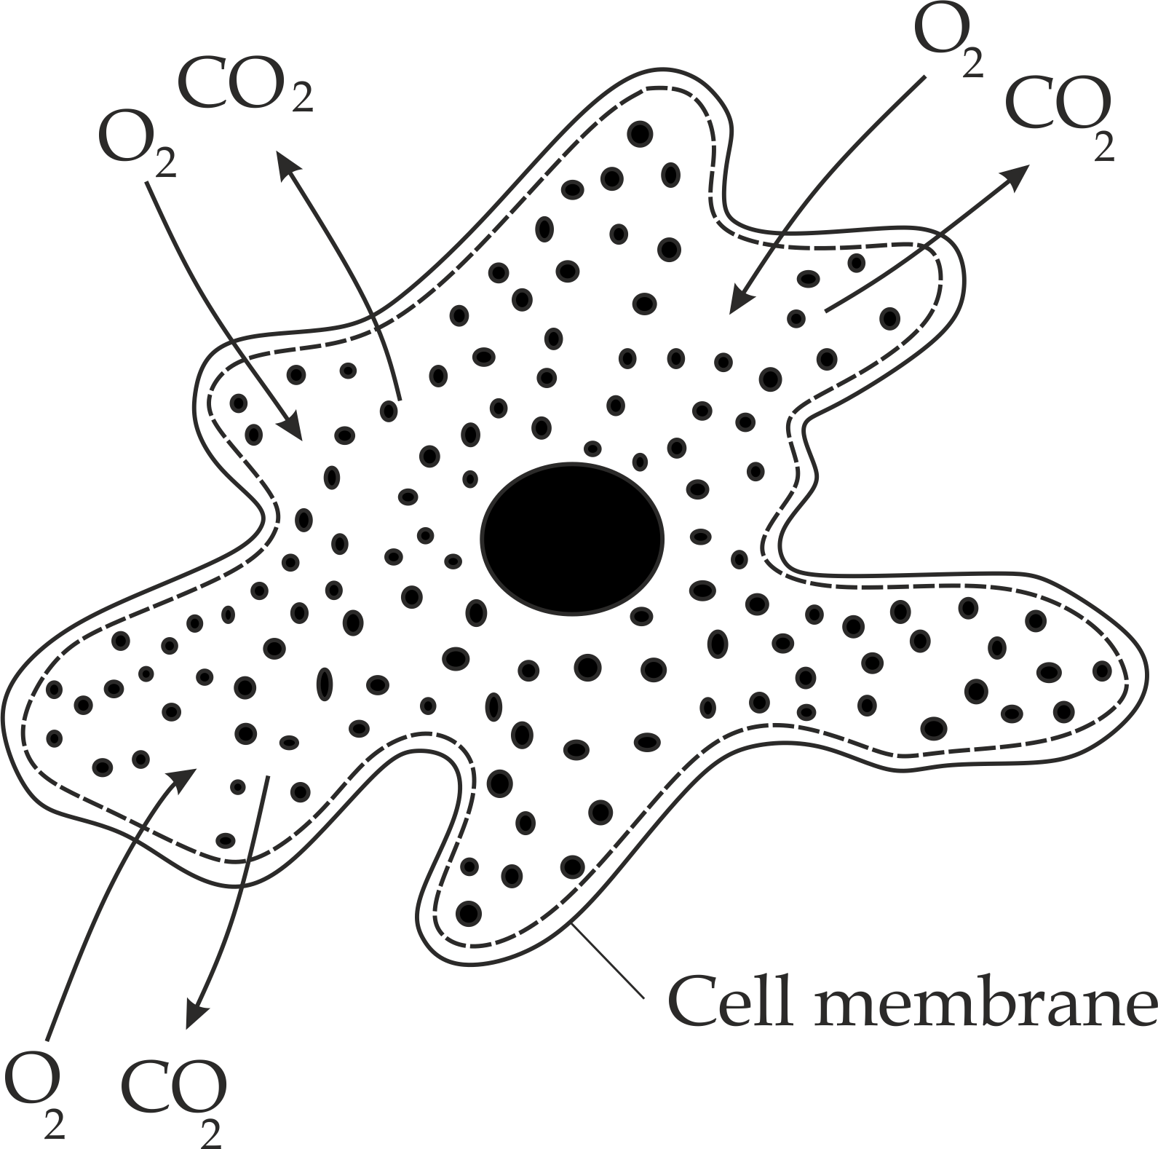

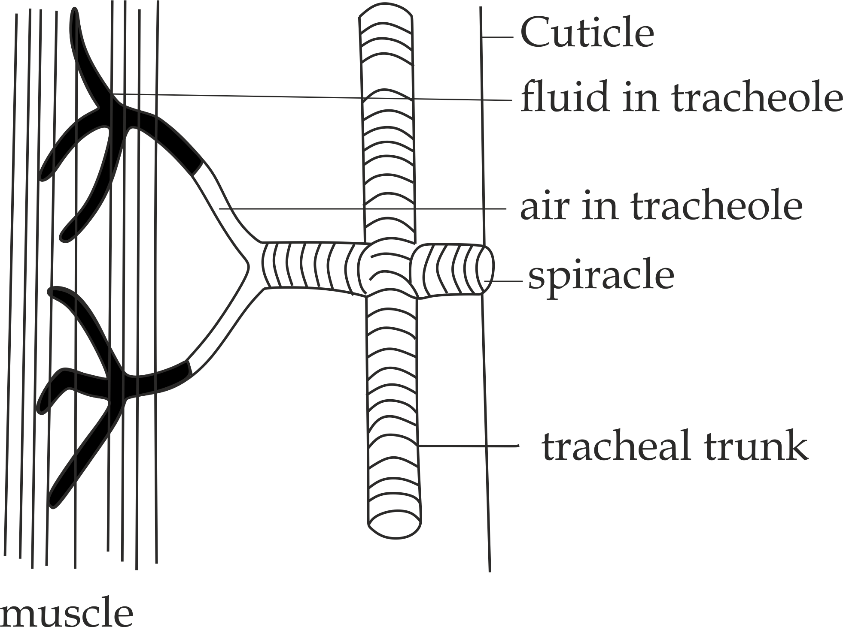

***Fig 4.1(b):*** *Gaseous exchange in amoeba across the cell membrane by simply diffusion*

***Fig 4.1(a):*** *Tracheal system in insects*

1. **Gaseous exchange in large animals with flattened or thin shape**

Moreover in multicellular animals with *flattened* or *thin shape* such as **flatworms** and **earthworms,** yet have evolved no specialized respiratory surfaces, the whole external surface of this animals are more efficient surfaces for gaseous exchange.

**Respiratory surfaces:**

These are specialized tissues whereby the gaseous exchange takes place in living organisms.

**What are the adaptive features common to all respiratory surfaces?**

Gaseous exchange can occur when the respiratory surfaces have the ability to speed up or slow down the exchange rate to meet the body demands. In general, for an efficient gaseous exchange, the respiratory surfaces must have the following adaptive features;

1. **Thin epithelium membrane**

It ensures rapid diffusion of the gases into and from the respiratory surfaces.

1. **Large surface area of the membrane**

It ensures the maximum rate for the diffusion of respiratory gases into and from the respiratory surfaces.

1. **Permeable membrane**

It allows the free passage of respiratory gasses across the thin membrane.

1. **highly supply of blood capillaries**

For transportation of respiratory gasses away from the respiratory surface which is necessary to maintain a diffusion gradient.

1. **Moist surface**

It dissolves the respiratory gases for rapid diffusion process in a solution.

**Sample question – 01**

**Style 1: Necta 1999**

* State the features of the respiratory surfaces which are common to all vertebrates and briefly explain the importance of each feature.

**Style 2: Mtwara and Lindi Mock 2022**

1. State the features of respiratory surfaces which help to:
2. Dissolve respiratory gases.
3. Maintain diffusion gradient.
4. Allow passage of gases.
5. Ensure rapid rate of diffusion of gases.
6. Explain how oxygen gas (O2) is transported in mammalian blood.



**Table 1.1 Examples of the respiratory surfaces in animals**

|  |  |
| --- | --- |
| **Respiratory surface** | **Animal** |
| Lungs | **Vertebrates**   * Mammals * Reptiles * Birds * Amphibians |
| Gills | * Fish * Tadpole amphibians |
| Skin | **Adult amphibian**   * Frog |
| Tracheoles | **Insects**   * Grasshopper * Locus * Praying mantis |
| Lung book | **Arachnids**   * Spider * Scorpions |
| Cell surface membrane | **Protozoans**   * Amoeba * Paramecium   **Less active animals**   * Hydra * Sea anemones * Sponges   **Flat and thin animals**   * Flatworms * Earthworms |

**Parallel flow and counter current flow in fish**

In fish gills, water and blood flow close to each other and gaseous exchange takes place from one to the other. If the blood and water flow in the same direction at the same speed **(parallel** **flow)** the concentration difference in dissolved oxygen would be great at first, but would steadily decrease as the blood and water flowed together across the gaseous exchange *(Fig 4.2; a,b)*. Parallel flow is not therefore very efficient.

Cartilagenous fish – **the sharks** and **rays** – have parallel system and extract only about 50% of the oxygen from the blood.

For maximum gaseous exchange to take place it is the best for blood and water to flow in opposite directions **(counter current flow)**, this normally ensures a steep diffusion gradient throughout the gaseous exchange surface as the results a blood leaves the gill plates it has a partial pressure of oxygen almost as great as that of incoming water *(Fig* *4.2: a, b)*. The bony fishsuch as tilapia, with their counter current systems, remove about 80%.

***Fig 4.2a*** *Parallel flow mechanism in Cartilagenous fish*

***Fig 4.2b:*** *Counter current mechanism flow in bony fish*

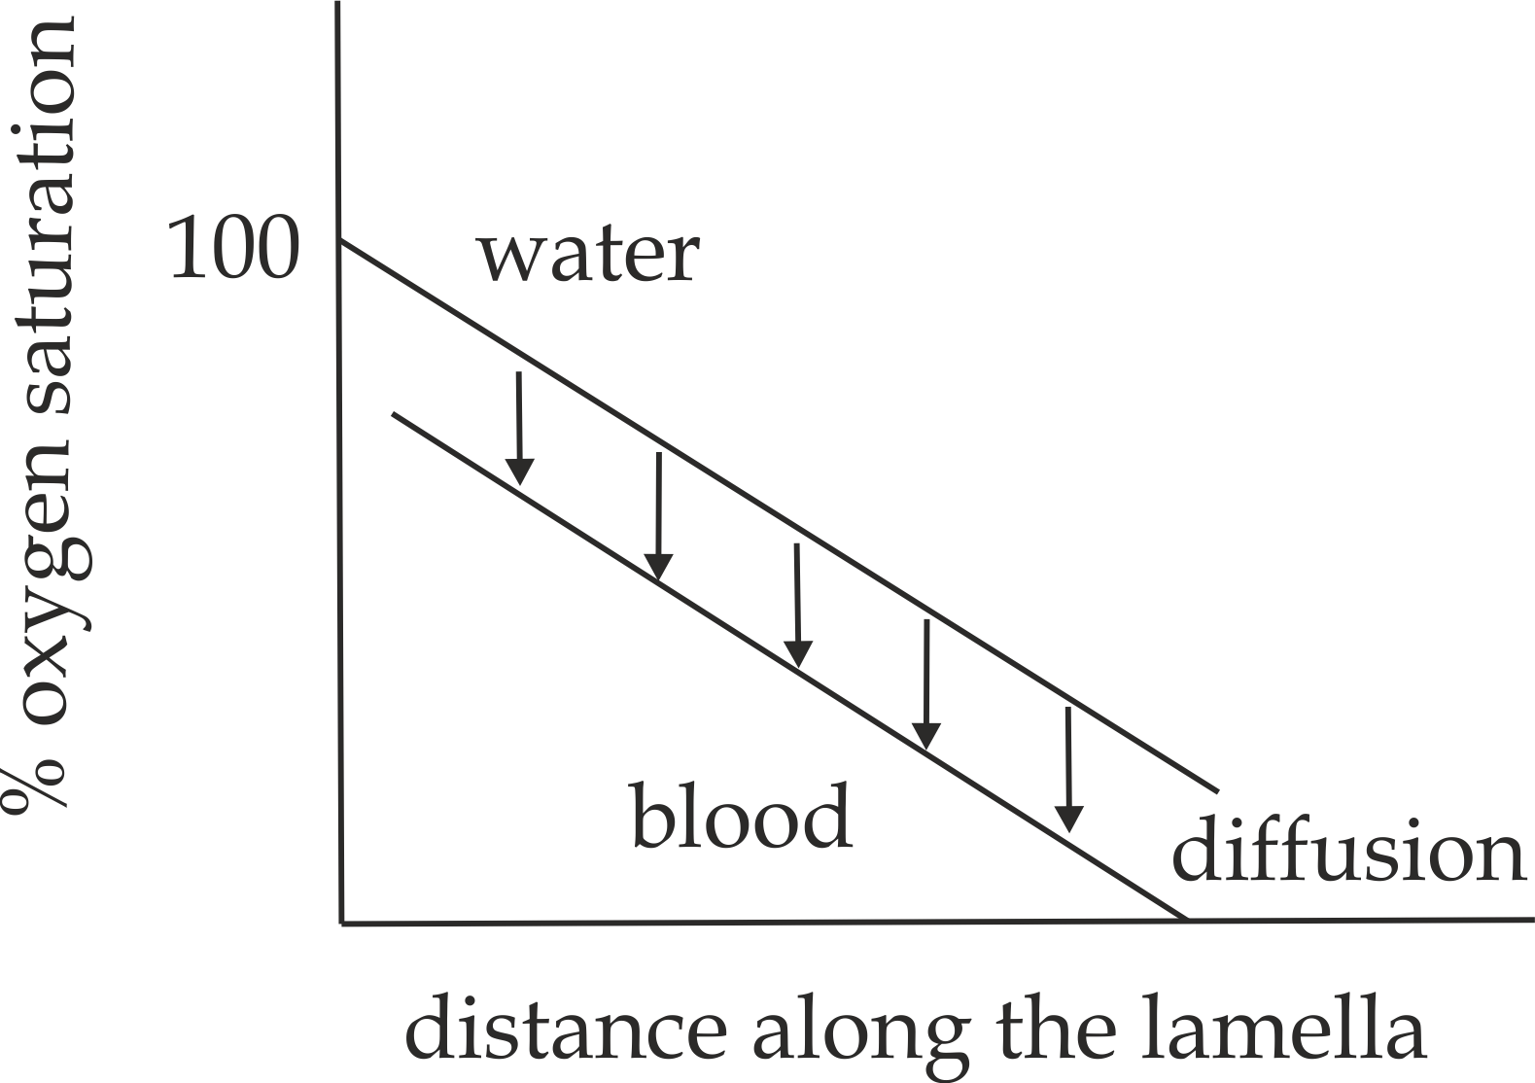

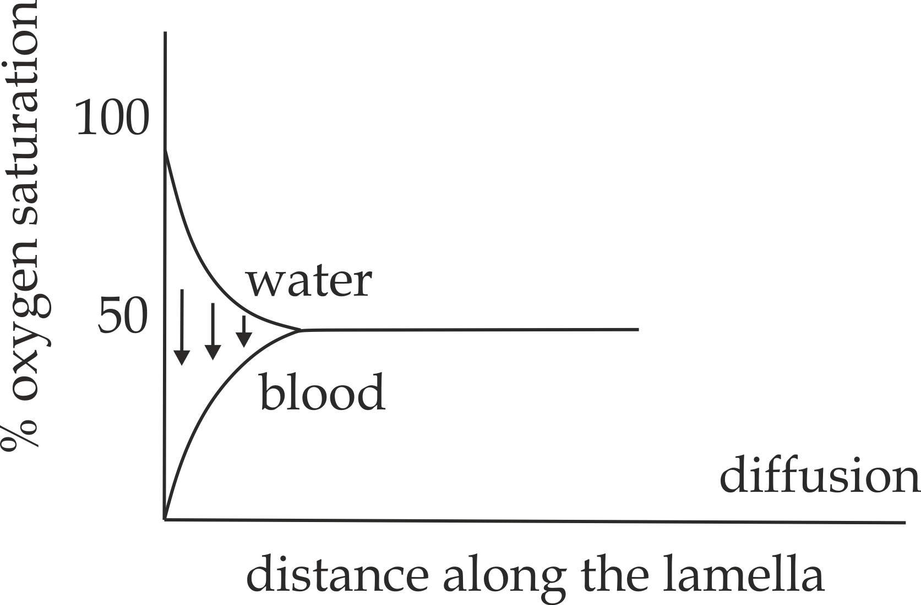

**Sample question – 02**

**Famous BS question**

* By giving examples explain why a counter current system would be more efficient mechanism for exchange of gas than a parallel current system.





***Did you know?***

***“The abdomen of praying mantis is always in constant motion for rapid diffusion of gases into and from the tracheal system“.***

**4.2: GASEOUS EXCHANGE IN MAMMALS**

**4.2.1: The concept of breathing**

**Breathing** is the movement of air into and out of the lungs. It is also known as **ventilation.**

**Mechanism of breathing**

The process of breathing (movement of air) depends on the pressure gradient different between the lungs and the atmosphere by changing the volume of the lungs caused by the movement of the **intercostal** and **diaphragm muscles.** Usually the air pressure inside the lungs is varied; Air normally moves from a region of high pressure to a region of low pressure. Due to this movement of air mechanism of breathing is divided into two (2) processes; **inspiration** and **expiration.**

1. **Inspiration**

**Inspiration** is the movement of air into the lungs*;* ***Inspiration*** is usually referred to as active phase of breathing, because, because it involves the contraction of diaphragm and external intercostal muscles by using ATP – energy.

**Mechanism of inspiration:**

During inspiration the following events take place so that air can be taken into the lungs.

1. The external intercostal muscles between the ribs contract, this pushes the ribcage upward and outward.
2. The diaphragm muscles contract – this flattened the diaphragm.
3. The volume of chest cavity increases and pressure around the lungs decrease to less than atmospheric pressure.
4. The air is drawn into the lungs, thus **inspiration** as in *Fig 4.2***.**

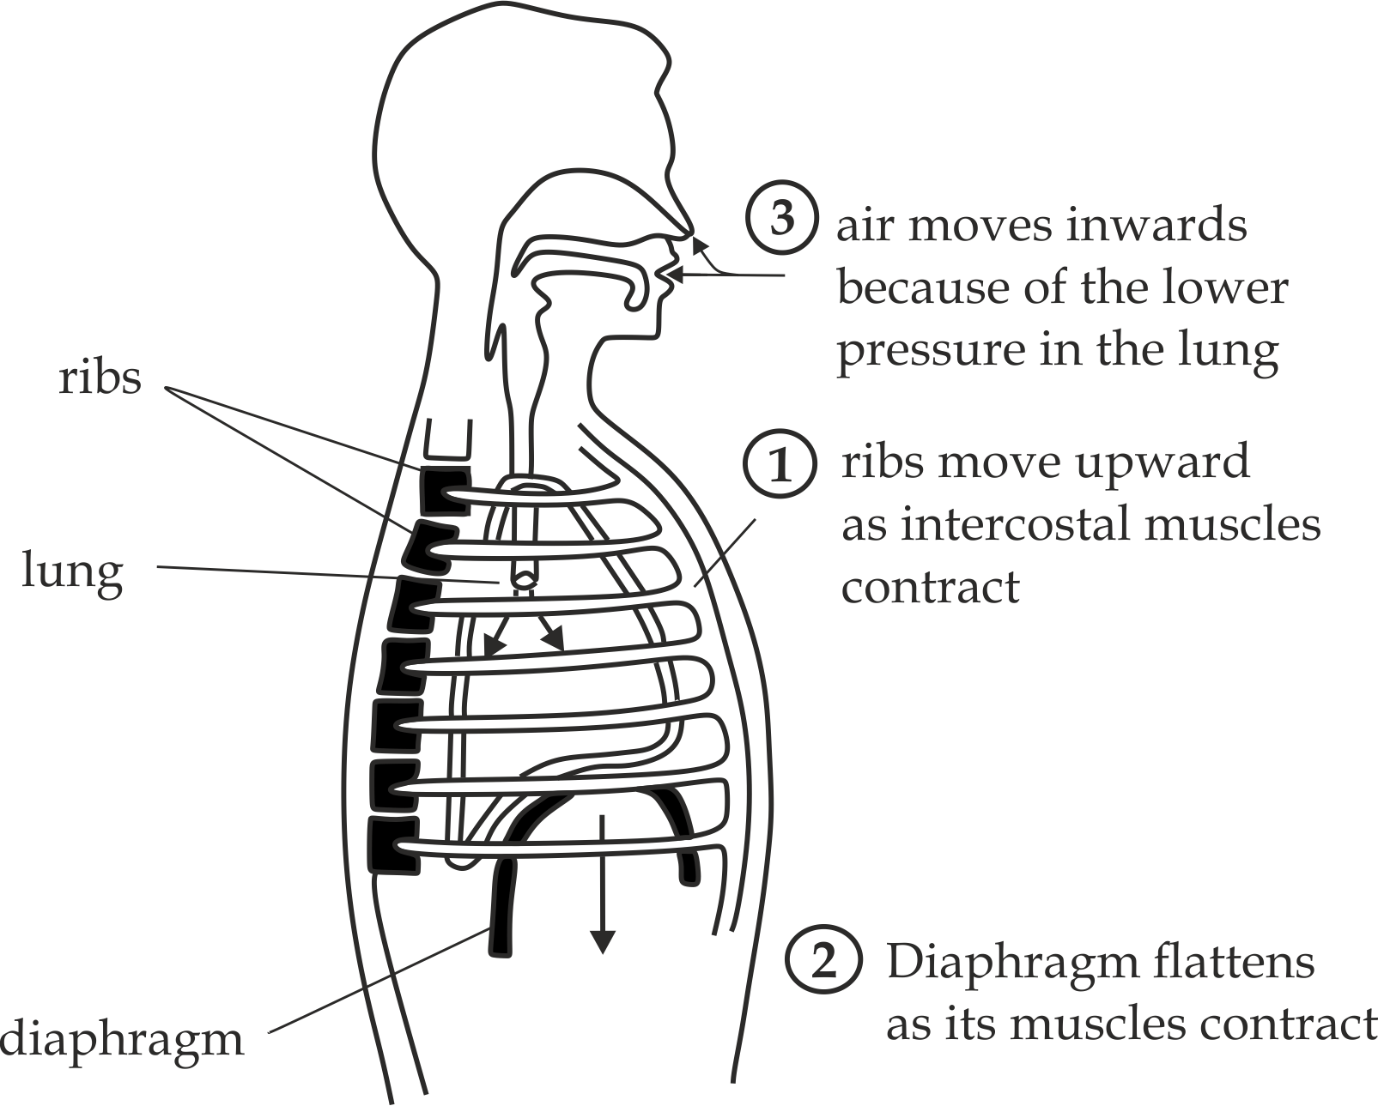

***Fig 4.2*** *Breathing in (Inspiration)*

1. **Expiration**

**Expiration** is the movement of air outside the lungs. It is usual passive process resulting from elastic recoil of the tissues that have been stretched during inspiration. However, in forced breathing or when the breathing tubes are blocked; expiration is aided by the contraction of the **intercostal muscles** and **abdominal muscles** which raise the pressure in the abdomen, forcing the diaphragm up wards.

**Mechanism of expiration:**

During expiration the following events take place:

1. The external intercostal muscles relax which pull the ribs downward and inward.
2. The diaphragm muscles relax which the diaphragm upward.
3. The volume of chest cavity decreases and pressure around the lungs increase to move than atmospheric pressure.
4. The air is expelled outside the lungs hence **expiration** as *Fig 4.3***.**

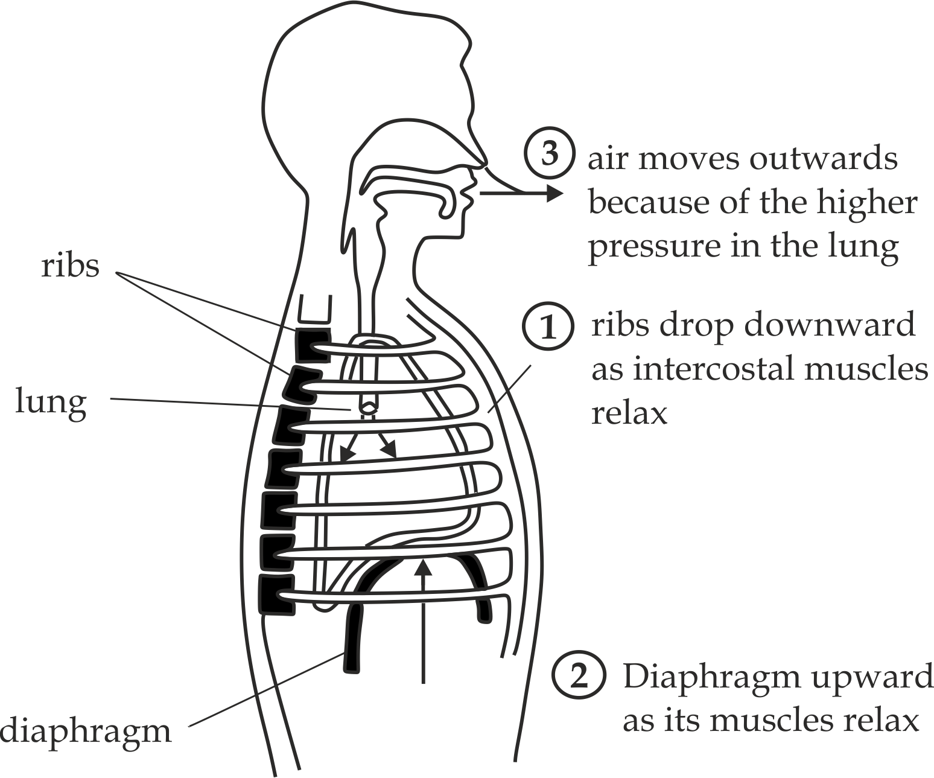

***Fig 4.3*** *Breathing out (Expiration)*

**Sample question – 03**

**Necta 2010**

* Describe the mechanism involved during breathing inspiration in humans.



**Advantages of nose breathing**

It is advised to breath air into the lungs through the nose and not through the mouth, because the nose has structures necessary for healthy breathing which include the following:

1. **mucus:**
2. It moist the air to make it suitable to dissolve into the blood.
3. It sticky easy the trapped particles and bacteria.
4. **cilia**
5. Trapping/*sticking* dust particles and bacteria coming in with air.
6. **Blood vessels**
7. Warm the air normally to a temperature close to the body’s heat.

**Sample question – 04**

**Necta 2010**

* Why is it advised to breathe air into the lungs through the nose and not through the mouth?



***Medical application 01***

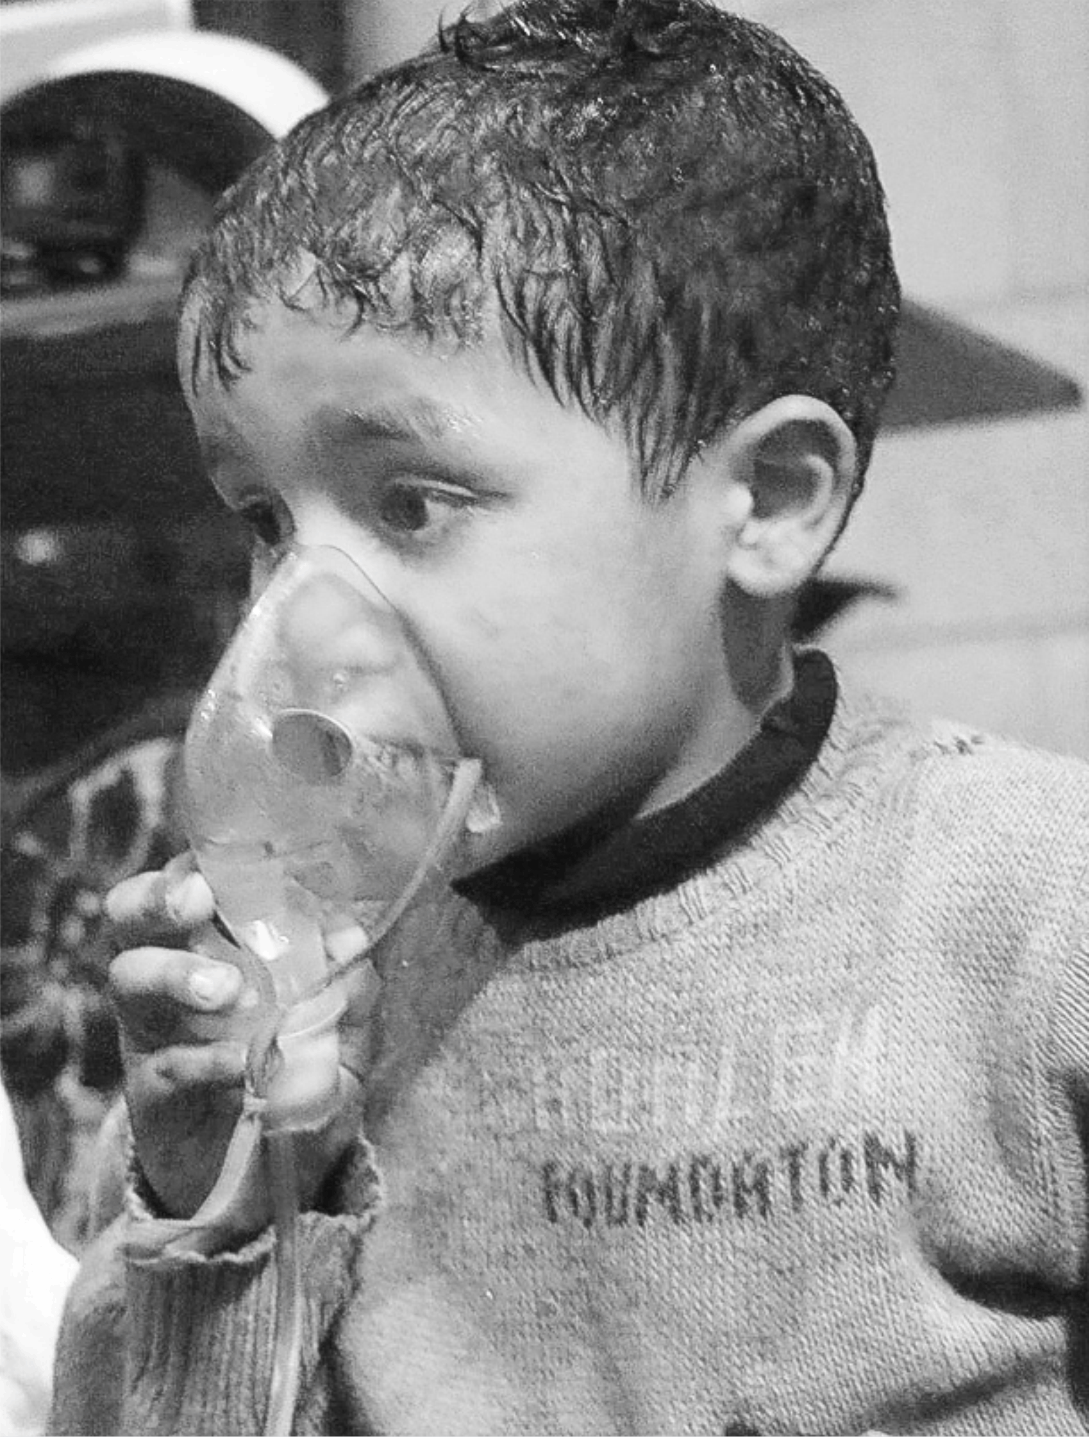

***Fig 4.4:*** In developed countries, asthma is becoming more common disease, especially in young people. This boy is using oxygen gas due to the blockage of his bronchioles.

**Control of breathing mechanism**

The rate of breathing is usually adjusted to meet the body’s immediate needs. During periods of increased activity mammals ventilate the lungs more deeply and more rapidly to increase supply of oxygen, and also eliminate from the body’s the additional carbondioxide produced by increased respiration. The breathing rate slows down when the demand for oxygen falls during periods of rest. i.e., human adult breathes about 15 – 20 per minute at rest. Breathing is involuntary controlled by the **breathing centre** of medulla hind brain contain chemoreceptors sensitive to the change in carbondioxide level in the plasma; The **inspiratory centre** which send impulse to stimulate **inspiration** and the **expiratory centre** which send impulse to stimulate **expiration as shown in** *Fig 4.5***.**

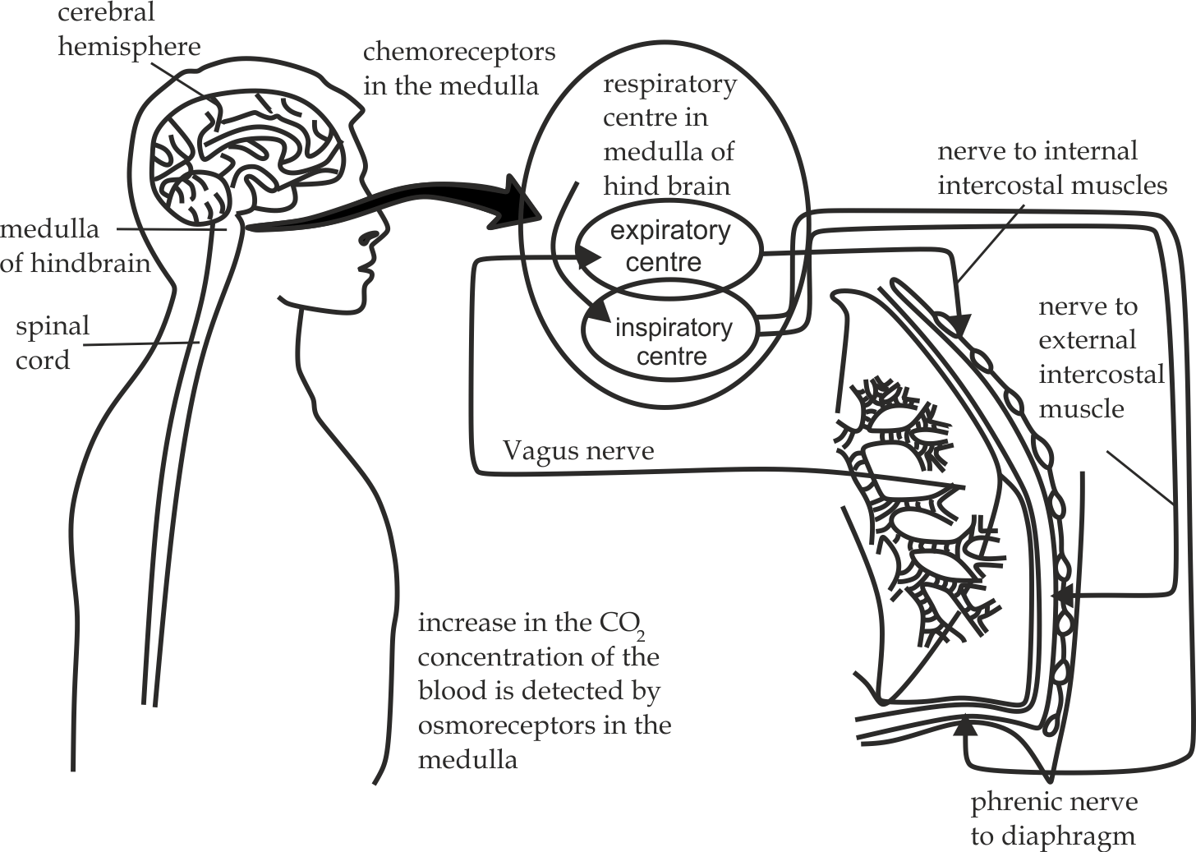

***Fig 4.5*** *Control of breathing mechanism*

**Sample question – 05**

**St Anne Marie high school 2017**

1. Briefly describe how the gaseous exchange occur across the alveoli?
2. Precisely show the mechanism evolved during breathing
3. What control the mechanism above?





***Did you know!***

***“When a person fail to maintain adequate oxygenation or carbondioxide elimination may develop acute respiratory failure*** *i****n******which death may result“.***

**The Percentage composition between inhaled and exhaled air.**

|  |  |  |
| --- | --- | --- |
| **Gas** | **Inhaled** | **Exhaled** |
| Nitrogen | 78% | 78% |
| Oxygen | 21% | 16% |
| Carbondioxide | 0.03% | 4% |
| Water vapour | variable | concentrated |

The interpretation of the percentage of inspired and expired air:

* **Nitrogen gas**

The composition of nitrogen gas is usual constant *(78%)* between inhaled and exhaled air. **Reason**; there is no any cell metabolism which can use or produce nitrogen gas.

* **Oxygen gas**

The composition of oxygen gas decrease by 5% from 21% inhaled to 16% exhaled. **Reason;** some of the 02 gas is produced from the oxidation of glucose.

* **Carbondioxide gas**

The composition of carbondioxide gas increases by 3.97% from 0.03% inhaled to 4% exhaled. **Reason;** some of the C02 is produced from the glucose oxidation and also produced from the breaking down of HCO3-.

* **Water vapour**

The inhaled water vapour is variable.

**Reason;** It depends on the humidity of the atmosphere. The exhaled water vapour is concentrated. **Reason;** some of the water vapour is coming from the oxidation of glucose.

**Sample question – 06**

**Dar Mock 2018**

The composition of gasses in the inspired and expired air is summarized as shown below:

|  |  |  |
| --- | --- | --- |
| **Gas** | **Inspired air (%)** | **Expired**  **Air (%)** |
| Nitrogen | 78 | 78 |
| Carbondioxide | 0.03 | 4 |
| Oxygen | 21 | 16 |
| Water | variable | concentrated |

**Interprets;** the percentage composition of the inspired and expired air.



**4.2.2: The mammalian lungs**

The **mammalian lungs** are the primarily organs for gaseous exchange. The lungs of a mammal are situated in the **thoracic cavity** or **thorax**. The walls of the thorax are protected by the ribcage and its floor consists of muscular sheath known as the **diaphragm** which usually separates the thorax from the abdomen. In the humans the rib – cage consists of twelve pairs of ribs and intercostal muscles that allow its movement during inspiration and expiration of air. Lungs are covered by the double membranes (inner viscera and outer parietal) between which pleural fluid is found which serves as lubricant, preventing abrasion of lungs during breathing.

**The internal structure of human lungs**

The internal structure of the human lungs consists of the trachea, bronchi, bronchioles, alveolar ducts, alveolar sacs and alveoli as shown in *Fig 4.6*.

* The **trachea:** The human trachea is a tube running from the pharynx (back of the mouth) to the bronchi. It is supported by C – shaped rings of cartilage which keeps the trachea open at all time and prevent its collapse during inspiration. The inside of trachea is lined by the **ciliated epithelium** and **goblet cells**. The **cilia** beating sweep the trapped dusts and bacteria to the nasal cavity whereby they get swallowed. The **goblet cells** are essential for mucus production that traps dusts and bacteria. The trachea branches at its lower end into two **bronchi** (left bronchus and right bronchus).
* The **bronchi** (singular bronchus); are two tubes branched from the trachea one of which enters the lung. Like the trachea, each bronchus has cilia and goblet cells which play a role of trapping dusts and bacteria. Each bronchus (left and right) subdivided into many smaller tubes known as **bronchioles.**
* The **bronchioles;** these are smaller tubes normally about 0.5 mm in diameter formed by the bronchus.

Bronchioles lack cartilage and are made up of flattened cuboidal cells which increase the surface area and a smaller distance for gasses to diffuse. Absence of cartilage makes them more easily to collapse. The bronchioles then are further subdivided several times into smaller and narrow tubes ending known as **alveolar ducts**.

* The **alveolar ducts;** At the terminal of each alveolar duct there are many number of sac like structures called alveolus which open into a group of alveolar sacs for maximum gaseous exchange. The alveolar ducts, sacs and alveoli do not contain cartilage, cilia and goblet cells.

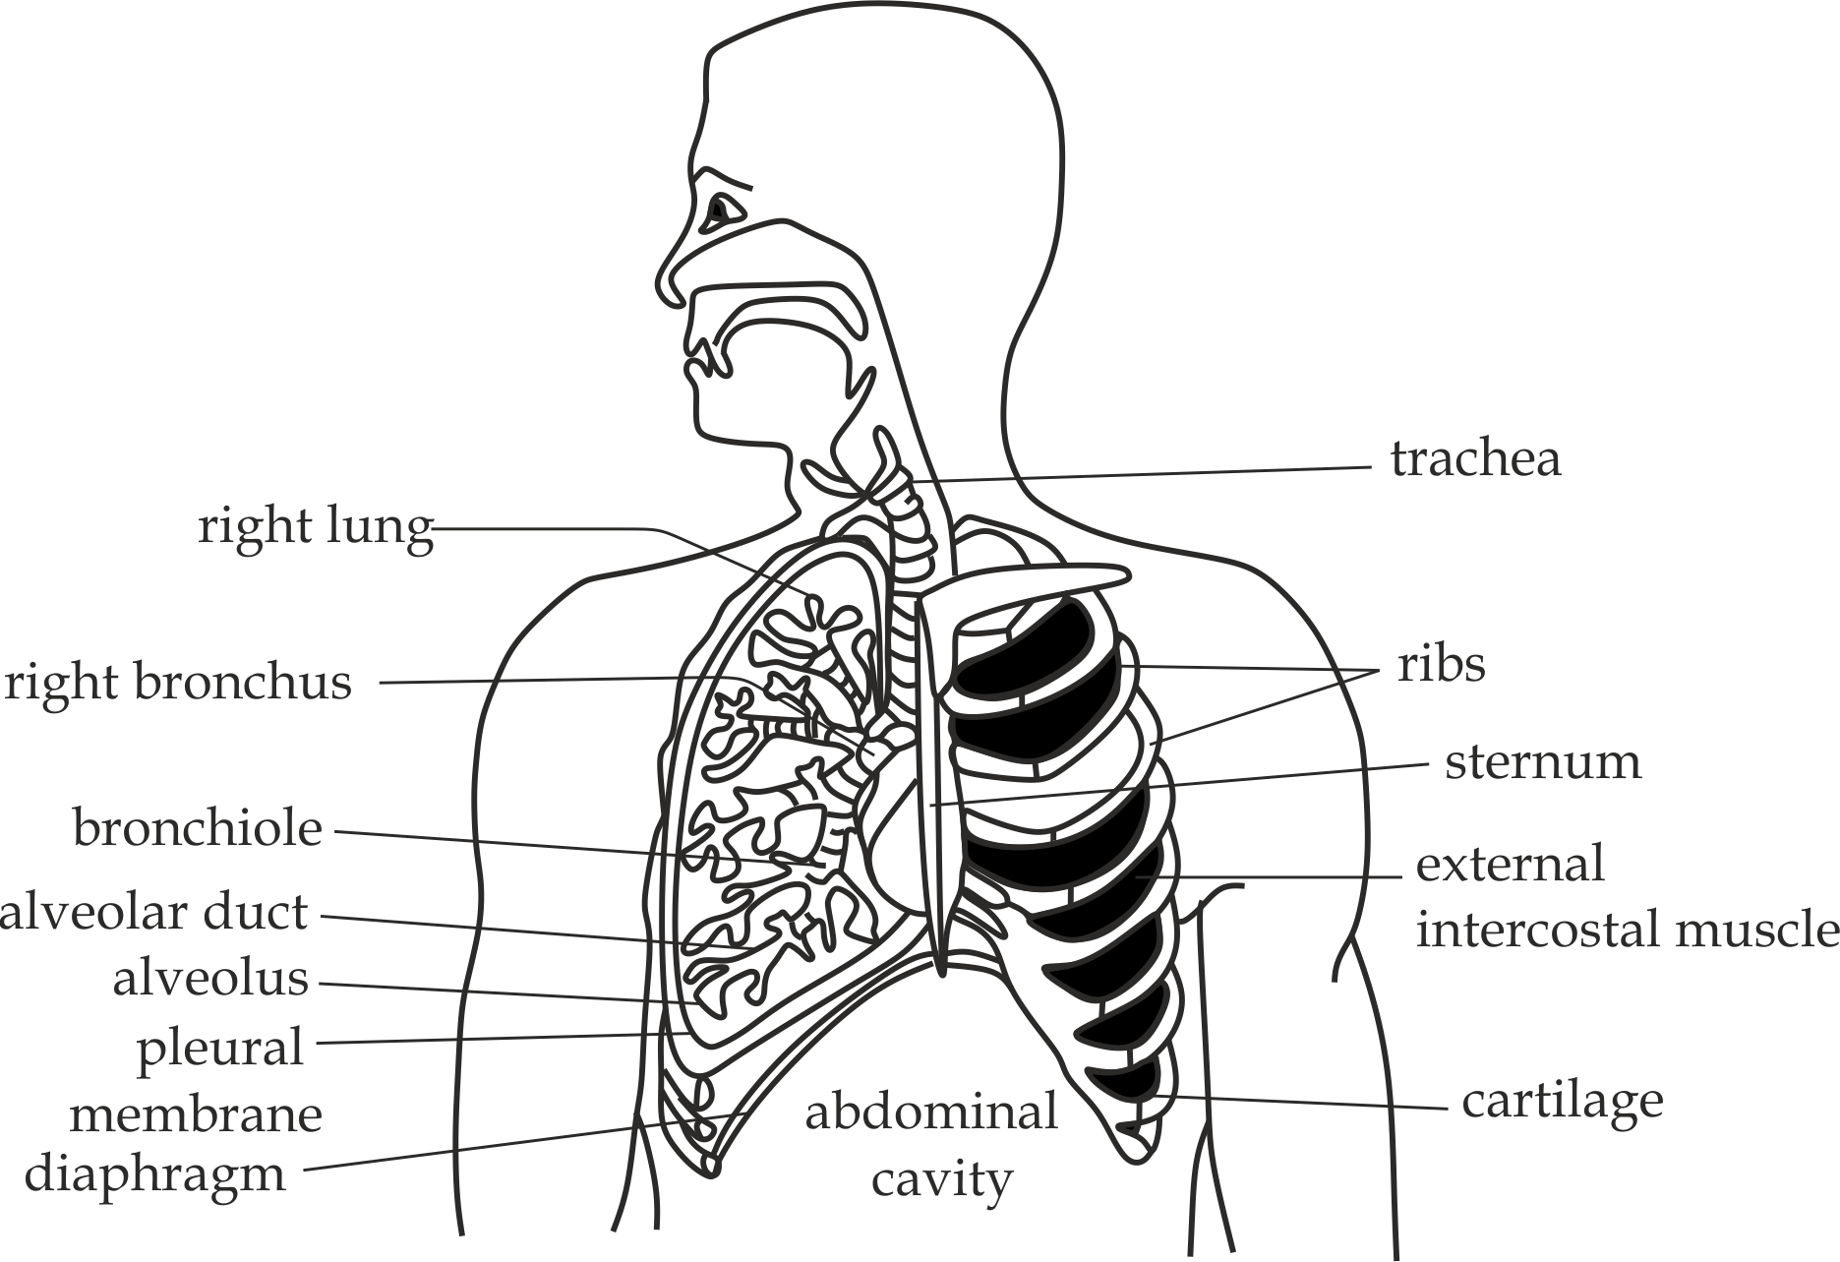

***Fig 4.6*** *Internal structure of human lungs*



**Sample question – 07**

**Necta 2014**

* Describe the internal structure of the mammalian lung; illustrate your answer.

**ALVEOLUS**

The **alveoli** *(Singular alveolus)* are a tiny air – filled sac whereby the maximum gaseous exchange occurs. Actually, it is a functional unit of the lungs. The estimated total amount of the alveoli in the average human is about 700 million that has a total surface area of over 80 square metres which facilitate the rate of gaseous exchange.

**Structure of alveolus**

The alveolus possesses connective tissues with elastic collagen fibres that allow them to expand and recoil during breathing, and alveolus is surrounded by the networks of blood capillaries for efficient gaseous exchange. Structurally, alveolus is made up of three (3) layers of cells; simple squamous epithelium, alveolus macrophages and surfactant – secreting cells as shown in *Fig 4.7*.

1. **Simple squamous epithelium**

It is a layer of thin and flattened cells inside the alveolus which ensures rapid diffusion of gasses.

1. **Alveolus macrophages (dust cells)**

These are protective cells in the alveoli that remove debris (dust) and microbes by phagocytosis.

1. **Surfactant – secreting cells**

These are cuboidal cells found within the walls of alveolus that secreting lipoprotein detergent – like chemical known as **surfactant** into the alveolar space.

**Roles of surfactant**

1. It lowers the surface tension of the fluid lining inside the alveolus by interfering with the attraction forces between water molecules, hence reducing the energy required to breathe in and inflate the lungs.
2. It contains antiseptic agents which kill the bacteria trapped in the incoming air through the nostrils.
3. It increases the maximum rate of gaseous exchange in mammals.
4. It stops the tendency of fluid effusion in the lungs.

**Acute respiratory distress syndrome of the new-born (ARDS)**

**Acute respiratory distress syndrome** is the respiratory disorder caused by the lack of chemical detergent called surfactant in premature new-born baby; it is normally characterized by the following problems:

1. **Lungs malfunction** due to bacterial infection of the alveoli which may lead to respiratory failure. The most common bacteria are called streptococcus pneumoniae which cause pneumonia.
2. **Difficulty in breathing** due to lack surfactant as the result great effort needed to expand the alveoli which collapse after each expiration. This is the most common problems
3. **Lack of energy** required for various metabolic activities due to slow speed in the transportation of CO2 and O2 between the air and liquid lining the alveolus.

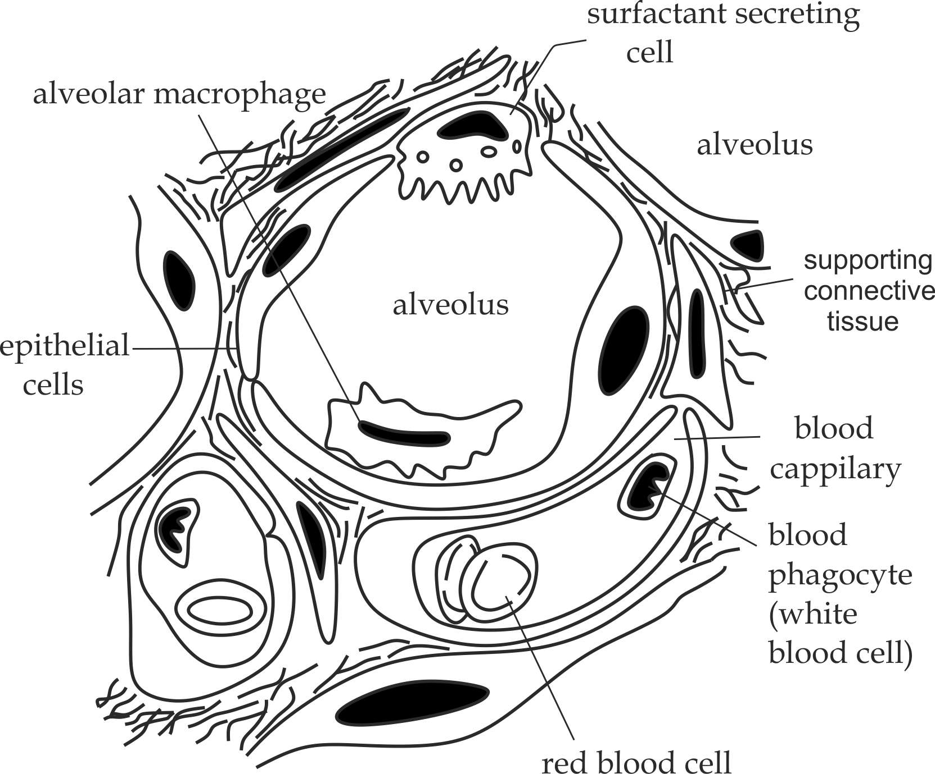

***Fig 4.7*** *The structure of alveolus*

***Medical application - 02***

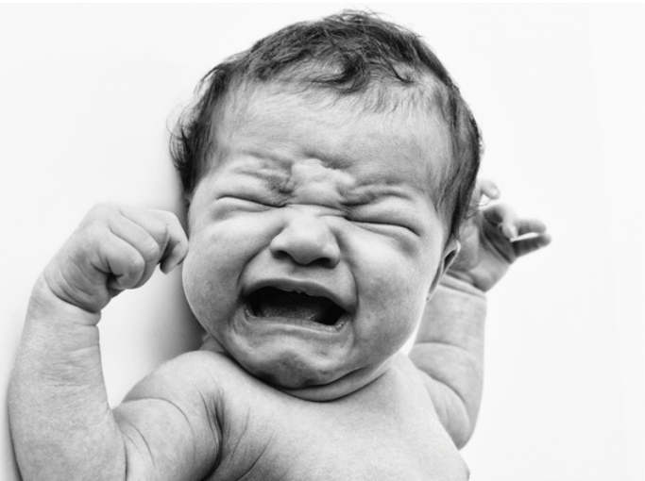

**Fig 4.8**

The first breath is usual the most important and probably the most very difficult experience of your life.

Very soon after birth the first breath must be taken. The first inspiratory effort is brought about by a very powerful contraction of the diaphragm. To successfully accomplish this breath the new-born infant has to exert a force **15** to **20** times greater than that needed for a mammal inhalation. As the result the lungs are greatly stretched and the elastic tissue they contain never again returns to its original length. Assuming that plenty of lung surfactant is present, the infant will then establish a breathing rhythm which will continue for the rest of its life.

**Sample question – 08**

**Eastern Zone Mock 2018**

1. Describe clearly the structure of alveolus of the mammalian.
2. Giant alveoli in lungs secrete a chemical substance called surfactant. State the role of this substance.
3. A baby was born with its lungs lacking surfactant. In three (3) points, briefly describe the respiratory problem that the baby will experience.



**Gaseous exchange at the alveolus**

**Oxygen gas** diffuses across the two thin barriers represented by the epithelium of the alveolus and the endothelium of the capillary. It passes first into the blood and then combines with haemoglobin in the RBC’S to form the oxyhaemoglobin. **Carbondioxide** normally diffuses in the reverse direction from the blood plasma to the alveoli through the same two thin barriers. Normally the retention of carbondioxide gas in the blood will spontaneously increase the rate of breathing for maximum gaseous exchange as shown in Fig 4.9.

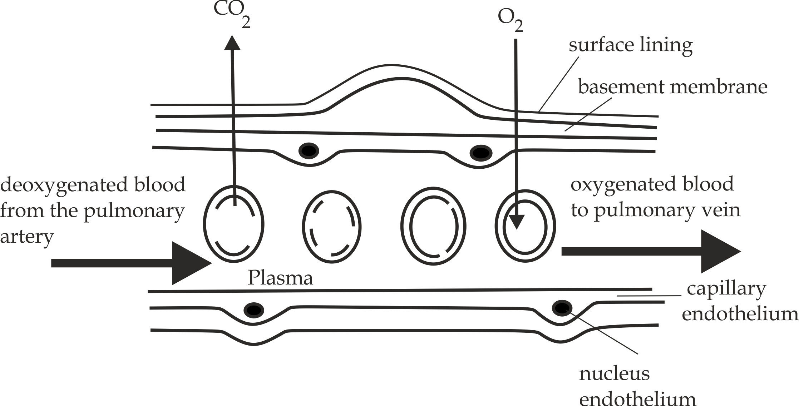

***Fig 4.9*** *Gaseous exchange at the alveolus*



**Sample question – 09**

**Necta 2004**

1. What are the properties of respiratory surfaces?
2. With the help of diagram describe how gaseous exchange occurs in the mammalian lung.

***Did you know?***

***“It has been estimated that if the alveoli in both lungs could be spread out flat they would cover the area of a singles tennis court“.***



**4.2.3: Transport of oxygen gas**

In vertebrates oxygen gas is transported in two ways; as a solution form and as oxyhaemoglobin.

1. **As a solution form (2%)**

Oxygen gas from the lungs dissolved in the blood plasma and transported as a solution, since oxygen gas is relatively insoluble in water, only about **2%** of the total oxygen gas is transported in this way.

1. **As oxyhaemoglobin (98%)**

In the highest partial pressure of oxygen gas such as lungs, the haemoglobin of the RBC’S combine with oxygen gas to form unstable and intermediate compound called **oxyhaemoglobin**. Usually Up to **four** oxygen molecules may be carried by each haemoglobin molecule.

Hb + 4O2 HbO8

(Hemoglobin) (Oxyhaemoglobin)

Near the body tissues .i.e. muscle tissues the oxyhaemoglobin dissociates into O2 and haemoglobin due to low partial pressure of oxygen gas and increase in the concentration of carbondioxide gas from the respiring cells.

HbO8  Hb + 4O2

(Oxyhaemoglobin) (Hemoglobin)

**Sample question – 09**

**Mtwara and Lindi Mock 2022**

1. Explain how oxygen is transported in mammalian blood.
2. State the significances of haemoglobin to have low affinity to oxygen at low partial pressure of oxygen.

**Hints (b)**

* It enables oxyhaemoglobin to release oxygen to the body cells.
* It enables haemoglobin to pick up carbondioxide from the body cells.



**Remember:**

**Loading and unloading oxygen**

* The process in which haemoglobin combines with oxygen is called **loading** or **associating** in humans this takes place in the lungs. E.g. this is measured at partial pressure of 10kpa **(loading tension)** whereby 95% of haemoglobin is saturated (haemoglobin is always never 100% saturated under normal 02 tension).
* The process in which haemoglobin releases its oxygen is called **unloading** or **dissociating** in human this takes place in the tissues.i.e. This is measured at partial pressure of 5kpa **(unloading** **tension)** whereby 50% of oxygen is present on haemoglobin.



**4.2.4: Oxygen dissociation curve**

**Oxygen dissociation curve**:is a graph which represents the partial pressure of oxygen gas (P’02) against the percentage saturation of oxygen to haemoglobin. It facilitating **loading** of haemoglobin with oxygen in the lung tissues due to high concentration of oxygen, also facilitate **unloading** in the tissues such as muscles due to low concentration of oxygen.

The oxygen dissociation curve is always **Sigmoid** (s – shaped). Why this shape? Shown in *Figure 4.10*.

The answer is that the S – shaped is due to the way in which oxygen binds with haemoglobin which can be interpreted as follows:

* At very low concentration of oxygen gas, the four (4) polypeptides of the haemoglobin molecules are closely united, and so it is difficult to absorb the first oxygen molecule this makes a graph to rise gently up to 5Kpascal partial pressure of oxygen gas.e.g, **Unloading tension**.
* However, once loaded, this oxygen molecule causes the polypeptides to load the remaining three (3) oxygen molecules very easily and the graph rises steeply up to 10 Kpascal partial pressure of oxygen, because a small change in partial pressure of oxygen has a great effect on the percentage saturation.e.g, **Loading tension.**

**In summary**:

Haemoglobin has a high affinity for oxygen where the oxygen tension is high (the lungs), but a low affinity for oxygen where the oxygen tension is low (respiratory tissues). This property makes haemoglobin an efficient respiratory pigment.

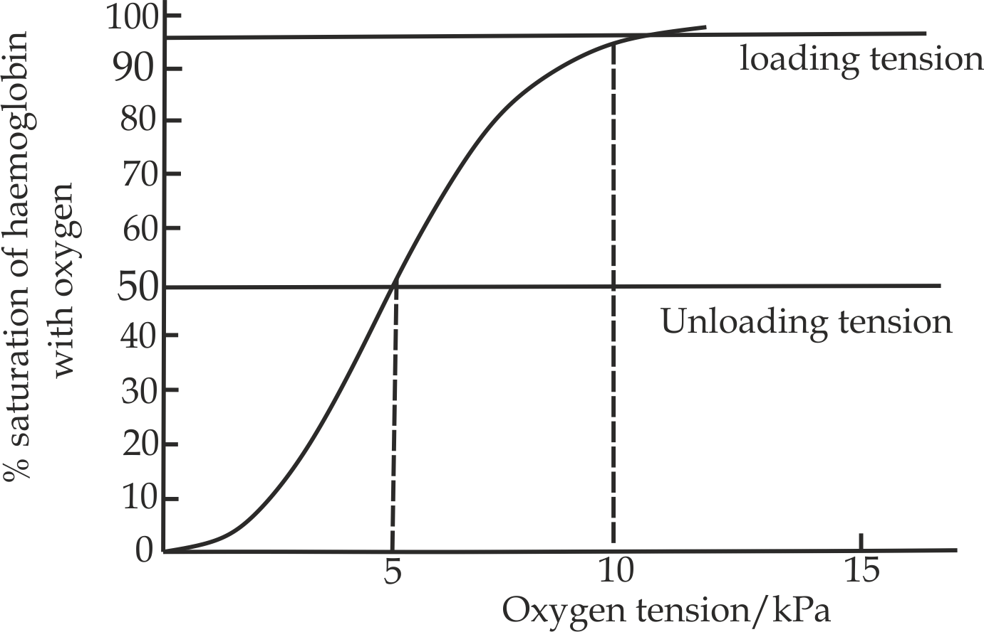

***Fig 4.10*** *Oxygen dissociation curve for haemoglobin*

**Loading tension**: Is measured at 95% saturation as Hemoglobin is never 100% saturated at normal oxygen tension.

**Unloading tension:** Is measured at 50% saturation as haemoglobin never release all its oxygen under normal condition.

**Sample question – 10**

**Dar Mock 2017**

* Explain, why oxygen haemoglobin dissociation curve is sigmoid shape?



**Factors influencing the haemoglobin binding affinity to oxygen gas**

Normally; the affinity of haemoglobin to oxygen gas up taking is affected by the following factors;

1. **Carbondioxide concentration**

The greater the carbondioxidepartial pressure in the blood reduces the binding affinity of haemoglobin for oxygen as the results the oxygen dissociation curve is shifted to the right side, since more oxygen is released; this is known as the **Bohrs effect** as shown in *Fig 4.12*.

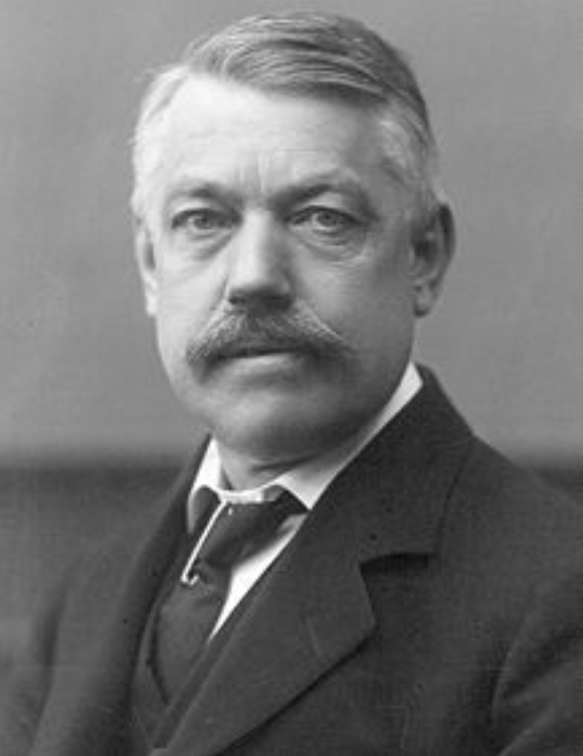

***Fig 4.11: Christian Bohr, who was credited*** *with the discovery of Bohr’s effect in 1904.*

**Bohr Effect or shift**: Is the lowering of the haemoglobin binding affinity to oxygen due to increase in the carbondioxide partial pressure of blood plasma. It is manifested by right – ward shifting of the oxygen dissociation curve**,** the effect of Bohrs shift was first described in **1904** by the Danish physiologist ″ **Christian** **Bohrs**”*(Fig 4.11).* The Bohr Effect is advantageous in that; it facilitates the releasing of oxygen to the muscles during respiration.

**Bohr’s** **effect** is an increase in carbondioxide partial pressure of the blood or decrease in blood pH resulting into lowering affinity of haemoglobin to oxygen.

***Did you know?***

***“Christian Bohr was the father of the Danish physicist Neil’s Bohr who proposed a structure of hydrogen atom***



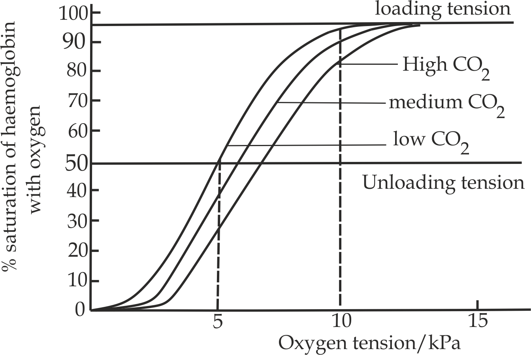

***Fig 4.12*** *Bohr Effect at different partial pressure of carbondioxide*

**Sample question – 11**

**Style 1: Tahossa Ilala 2020**

1. What is Bohr’s effect?
2. With illustration show the effect of carbondioxide on oxygen dissociation curve.



1. **Temperature**

The higher the temperature reduces the binding affinity of haemoglobin for oxygen as the result more oxygenis released readily and the oxygen dissociation curve is shifted to the right side as shown in *Fig 4.13*.

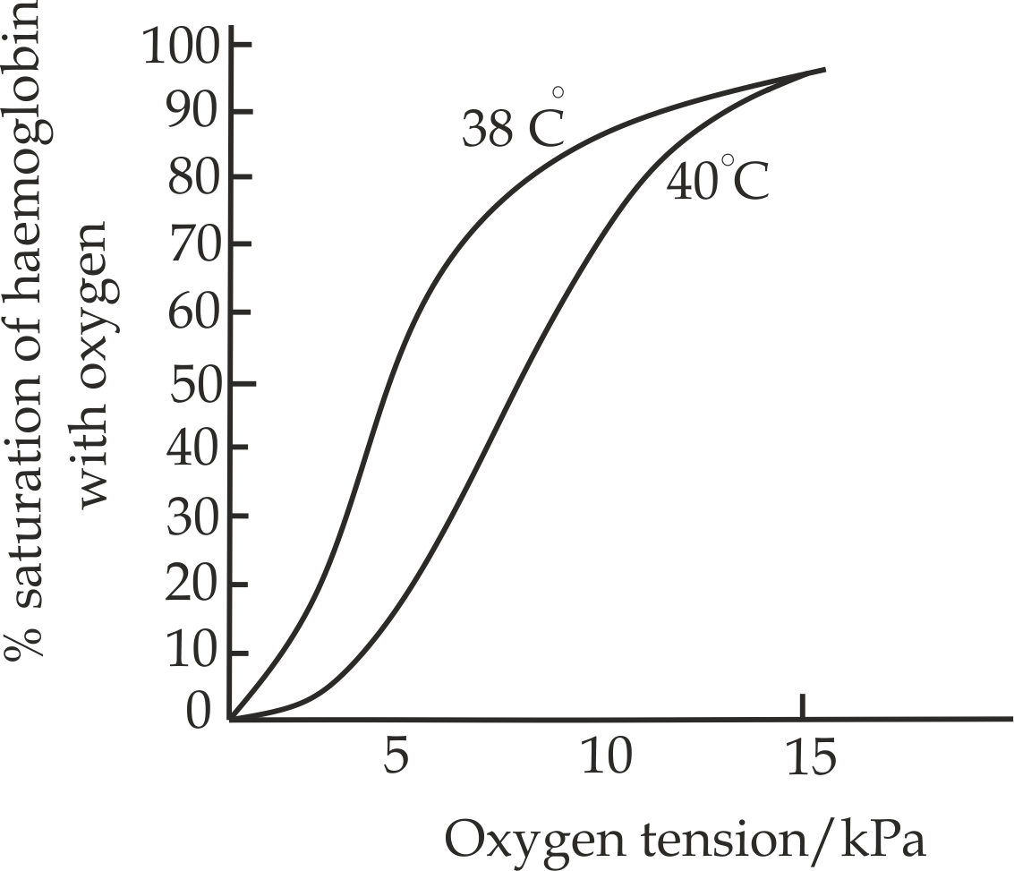

***Fig 4.13*** *The oxygen curves at two different temperature 37 ºC and 40 ºC*



**Sample question – 12**

**Dar Mock 2017**

The *fig 1* below is the graph which shows the oxygen dissociation curve of haemoglobin from an animal at two different temperatures 37℃ and 40℃.

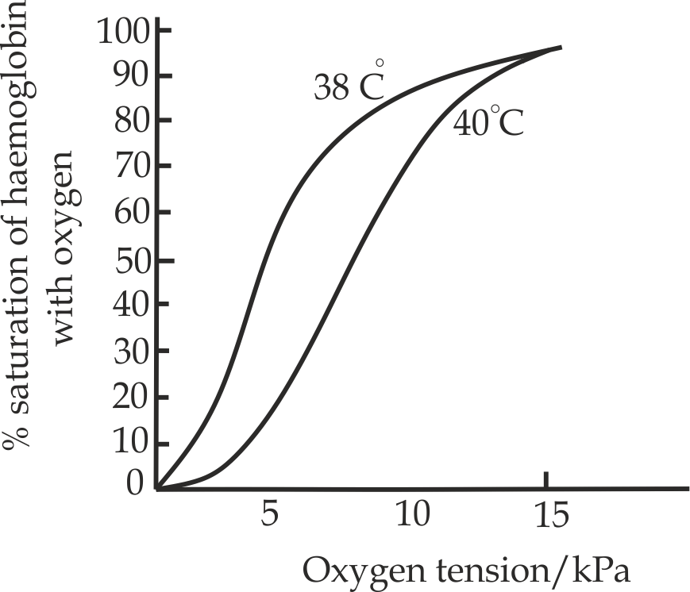

1. Why do the curves have sigmoid shape?
2. Explain the effect of temperature on the oxygen dissociation curve of haemoglobin to the animal.
3. **Body size**

Smaller animals such as mice have a larger surface area to volume ratio with high rate of metabolism that generate heat (temperature) which reduces the binding affinity of haemoglobin for Oxygen as the result the curve is shifted to the right side and larger animals such as elephant have lower surface area to volume ratio of metabolism that generate less heat to maintain body temperature as the result the binding affinity of haemoglobin to Oxygen increase and the oxygen dissociation curve will be shifted to the left side.

**Sample question – 13**

**Feza Boys terminal 2011**

* The oxygen dissociation curve is not the same for all animals. For example, compared with the human, the curve for small mammals is displaced to the right, Suggest why this is the case.



1. **The effect of carbonmonoxide**

Unfortunate property of haemoglobin is that; the affinity of haemoglobin for carbon monoxide is 300times stronger than its affinity for oxygen, carbon monoxide convert iron (II) to iron (III) in its reaction with haemoglobin, with the formation of carboxyhemoglobin, under this condition, oxygen is prevented from combining with haemoglobin and therefore the transport of oxygen around the body by the blood is no longer possible leads to respiratory failure, hence cause death. This makes carbon monoxide a powerful ″respiratory poison”

**Sample question – 14**

**Tahossa Kinondoni, Ilala and Temeke 2021**

* Why a person sleeping at night in a window closed room with burning charcoal is found silently dead?

**Hints:**

A person is found silently dead due to deficiency of oxygen in the closed room with burning charcoal, due to the fact that; when charcoal burns it releases carbonmonoxide(CO), CO has more affinity to oxygen, This result to prolonged shortage of oxygen and person suffocate and finally dies.



1. **Myoglobin**

**Myoglobin** is another respiratory pigment with high binding affinity to oxygen compared to haemoglobin. Myoglobin occurs largely in skeletal muscle tissue, and gives *″ meat”* its characteristics red color. The most important property of myoglobin is that it has a great affinity for oxygen than haemoglobin. As a consequence, myoglobin functions as an oxygen store in muscle tissues. When the demand for oxygen temporary exceeds the rate of supply, as it does in periods of prolonged and extremely muscular exertion, the oxygen of **oxymyoglobin** is release. If muscular activity persist after the myoglobin – based oxygen supply is also exhausted the muscles will move into **″ oxygen debt”,** then the muscles must respire by lactic acid fermentation. There are very high levels of myoglobin in the muscles of diving animals and in the flight muscles of flighted birds, Because of the high affinity of myoglobin for oxygen. The oxygen dissociation curve is hyperbola (more sigmoid) and not sigmoid and it is displaced to the left of the oxygen dissociation curve (*Fig 4.14)*.

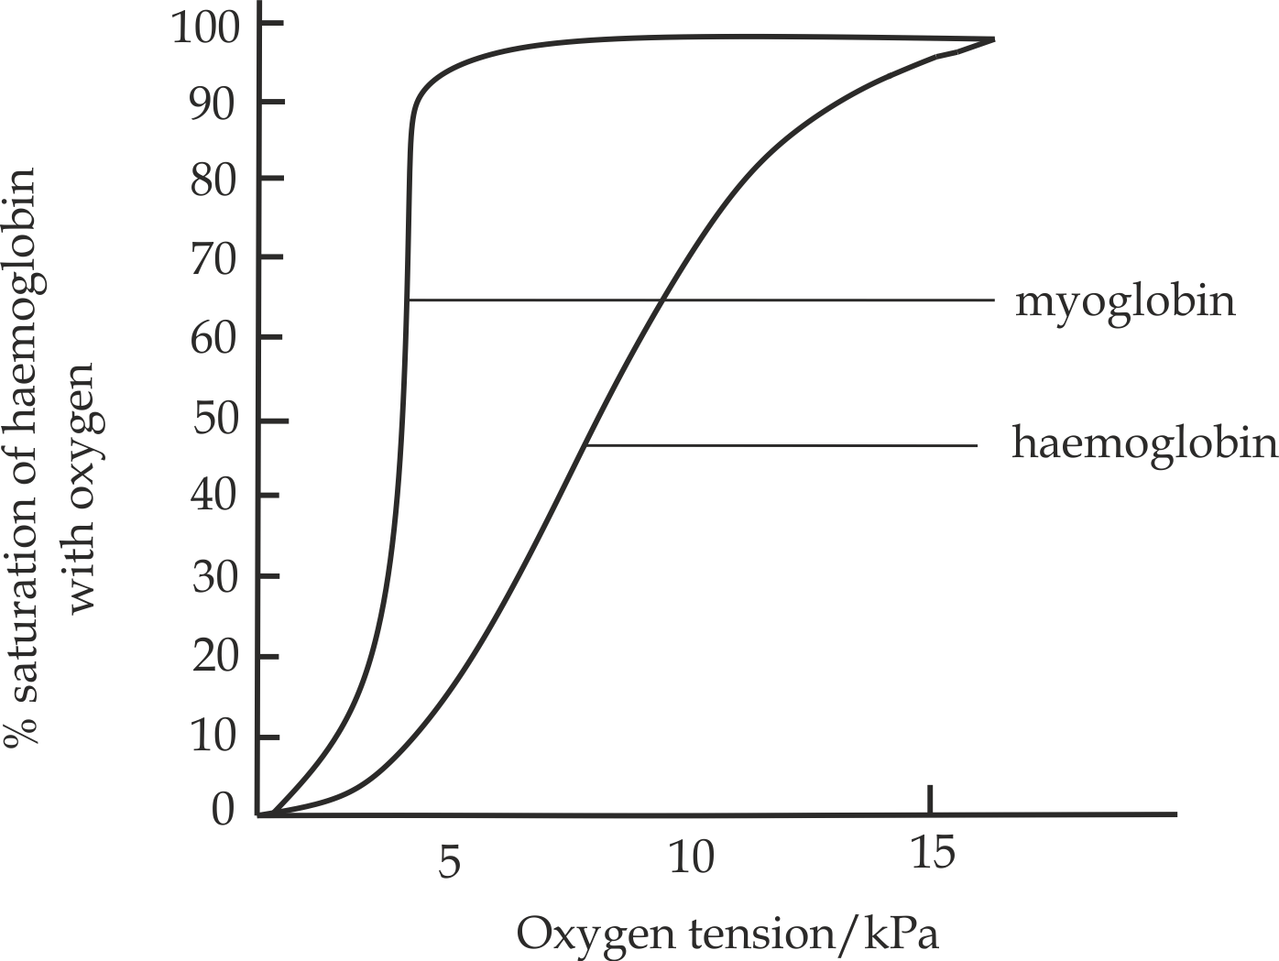

***Fig 4.14*** *oxygen dissociation curve of myoglobin and haemoglobin*

**Applications** **of Hemoglobin**

1. **Different lives – different haemoglobin**

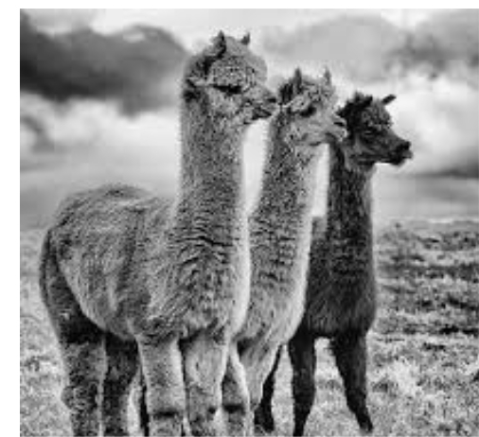

***Fig 4.15:*** *Llamas at high altitude*

* **High altitude:**

**Llamas** are animals that live at high altitude (*Fig 4.15*). At these altitudes the atmospheric pressure is lower and thus the partial pressure of oxygen is also lower. It is thereforedifficult to load the haemoglobin with oxygen, as the results the haemoglobin of Llama has higher affinity to oxygenso as to extract oxygen gas from the atmosphere and the curve is shifted to the left.

1. **Aquatic habitat**

Because there is less oxygen in water than in air the dissociation curves for aquatic organisms are usually to the left of those terrestrial ones, this is caused by the high affinity of haemoglobin so as to extract as much oxygen as possible from the water. This is accentuated in **lugworm** (Arenicola)which lives in muddy waterlogged burrows and other muddy dwelling fish where circulation of oxygen is limited.

1. **Terrestrial habitat**

**Air:** birds such **pigeons** have access to the 21% oxygen in air, and have addition advantage of powerful muscles for continuous ventilation of their lungs. In these circumstances the haemoglobin of pigeons has low affinity to oxygen as the result their oxygen dissociation curves are shifted to the right side.



**Sample question – 15**

**Possible at Any time**

* Consider three animals, Llama living at high altitude, human and mouse at low altitude, describe the oxygen dissociation curve of the haemoglobin of a given animals.

1. **Different ways of defensive – different haemoglobin**

The **mackerel** is a type of fish that swims freely in the surface water of the sea. These fish rely on their ability to swim very fast in order to catch the prey or escape from predators, thus have their haemoglobin with high affinity to oxygen so as to extract more oxygen from water for metabolism. The **plaice** is a marine fish that use a different strategy. These fish spend much of their time stationery or moving very slowing on the sea bed, where they are camouflaged by their skin color .The two fish are of similar mass.



***Did you know?***

***“Ice fish live in the Antarctic and are the only vertebrates to completely lack haemoglobin“.***

**4.2.5: Adaptations of oxygen up taking**

1. **Adaptations to oxygen uptake for mountain climbers**

The respiratory problems associated with living at high altitude are a result of the reduced atmospheric pressure. This makes difficult to load haemoglobin with oxygen, especially 2500 metres above the Sea level.

In Himalayan expedition of **1953**, *Fig 4.16* **Edmund** and **Sherpa Ten** **zing** (left) spend three hours at a height of over **8000** metres without oxygen apparatus, levelling snow and pitching a tent. It was not easy, but the fact that they managed to do it at all indicates the great importance of **acclimatization** as a main physiological process. An unacclimatised person at such a height would be unconscious within five minutes. Since then many other mountaineers have climbed Everest without the use of oxygen apparatus*.*

*The first climber ever to reach the summit of Everest 8000 m above sea level* ***(Fig 4.16)***

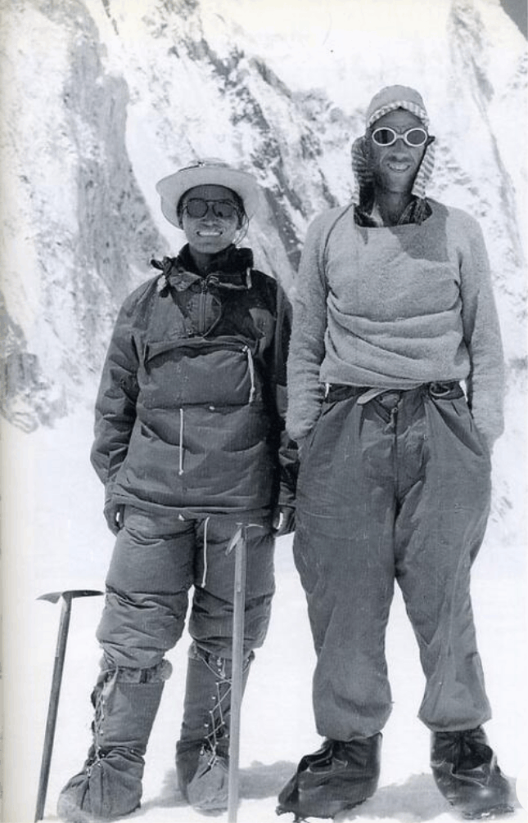

**Why mountain climbers feel breathless?**

The immediate effect of exposure to high altitude low oxygen level is faster breathing rate to obtain more oxygen, but this removes too much carbondioxide. This cause a small but significant rise in pH of the blood, this in turn removes the stimulus to the brain for breathing. The results are symptoms from lack of oxygen include breathless even at rest, dizziness, headache, fatigue, sweating, dim vision, nausea, reduced hearing and even loss of consciousness on physical exertion. These symptoms are known as **mountain sickness**.

**Adaptations of mountain climbers (dwellers)**

On the other hand a mountain dwellers or climbers who ascends slowly over a period of days or weeks has time to get adjusted to the low partial pressure of oxygen **(acclimatized)** by the following adaptive features:

1. They have deep and slow breathing rate that improve breathing efficiency for oxygen.
2. They develop larger number of alveoli and capillaries which increase the total lung capacity, therefore large amount of haemoglobin loaded with oxygen.
3. Their bone marrow produces more red blood cells in o6rder to raise the oxygen carrying capacity of the blood.
4. Tissues become tolerant to high levels of lactic acid due to oxygen deficiency.
5. Increased myoglobin concentration in the muscle for more storage of oxygen.
6. They excrete alkaline urine, the pH of the blood is return to normal, and the carbondioxide chemoreceptors become sensitive to the carbondioxide present so that normal ventilation rates are then maintained.

**Sample question – 16**

**Ilboru sec school 2002**

1. Discuss the effects of altitude on ventilation and describe how acclimatization is achieved by mountain dwellers.
2. Enumerate four adaptations to oxygen uptake for mountain dwellers.



1. **Adaptations to oxygen uptake for divers**

Divers in the deep water do not depend on lungs as s source of oxygen; instead they rely on enhanced oxygen stored in their blood and muscles. Collapse of the lungs forces air away from the alveoli, whereas gaseous exchange between the lungs and blood occurs. Thus, diving mammals, besides the collapse of their lungs, have the following adaptive mechanism to oxygen uptake:

1. Spaces are minimized; and nitrogen absorption is limited.
2. They develop slow heart rate to reduce oxygen consumption .For instance, seals reduce their heart beats from 150 to 10 beats minute.
3. Their bone marrow produces more red blood cells in order to raise the oxygen carrying capacity of the blood.
4. They have tissues tolerant to lactic acid and carbondioxide that is their muscles can work anaerobically while holding their breath.
5. They have develop large amount of myoglobin, almost ten times, this give them a chance of blood flow of storing oxygen for a long time when under water.
6. Most of blood flows to the vital organs only such as brain to reduce oxygen consumption.
7. They have high concentration of blood haemoglobin in order to ensure efficient transportation of oxygen gas.

***Medical Application 03***

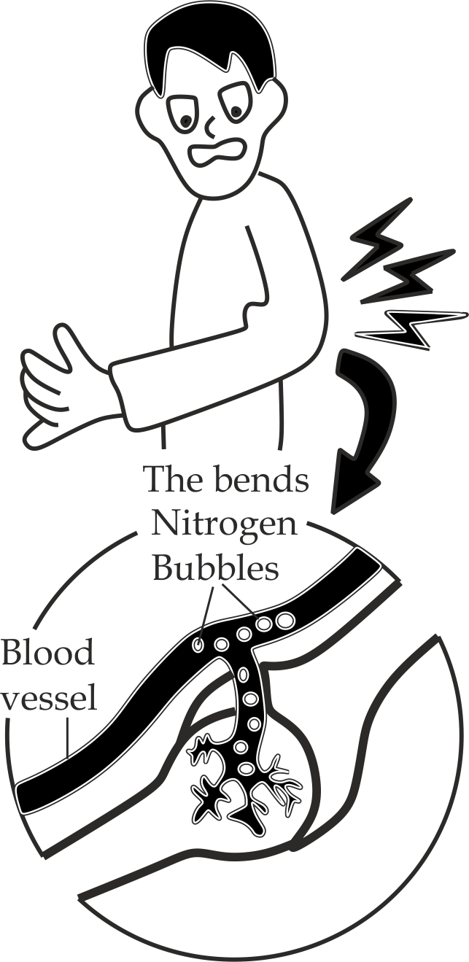

**Treatment:**

Recompression in a high – pressure hyperbaric chamber, in which the patient is put back under pressure and receive 100 percent oxygen.

The main problem facing the divers relate to the effects of pressure from surrounding water as many divers descends. This increase in pressure causes rapid absorption of nitrogen into the blood and the subsequently development of very high blood nitrogen pressure can exert a narcotic effect (so – called nitrogen narcosis) on the diver. It may also lead to nitrogen bubbles formation during ascends, a phenomenon known as **decompression sickness.** The bubbles cause severe pain which in turn give rise to terrible twists/ bends of the body. For this reason the condition is called the **″ bends”.**

**Other symptoms**

* **Unusual fatigue**
* **Skin itch**
* **Pain in joints, muscles of the arms, legs**
* **Dizziness, vertigo, ringing in the ears**
* **Numbness, tingling, tremors and paralysis**
* **Shortness of breath**

1. **Adaptations of the mammalian foetus to oxygen uptake**

The foetus lives and develop inside the maternal womb (uterus).It obtain nutrients, exchange gases (O2 and CO2) and waste products with the maternal blood via the placenta. For the foetus to obtain oxygen from maternal blood, the oxygen has to diffuse from maternal blood to foetus blood. There are some adaptations to this which are:

1. Foetal haemoglobin has higher affinity to oxygen; hence this allows the foetus to extract oxygen from the maternal blood supply. It has been shown that the structural changes in foetal haemoglobin caused by the substitution gamma subunits for beta chains, allows foetal haemoglobin to have a higher affinity to oxygen gas. As the results foetal haemoglobin curve is shifted to left side compared to adult haemoglobin curve as shown in *Fig 4.17*.
2. There is increased intake of oxygen gas by the maternal blood due to increased haemoglobin concentration so as to ensure a large supply of oxygen to the foetus blood.
3. The uterine wall (womb) is highly vascularized (provide with blood vessels) to ensure continuous supply of oxygen to the foetus, as a result, the foetus loads its haemoglobin with oxygen effectively.

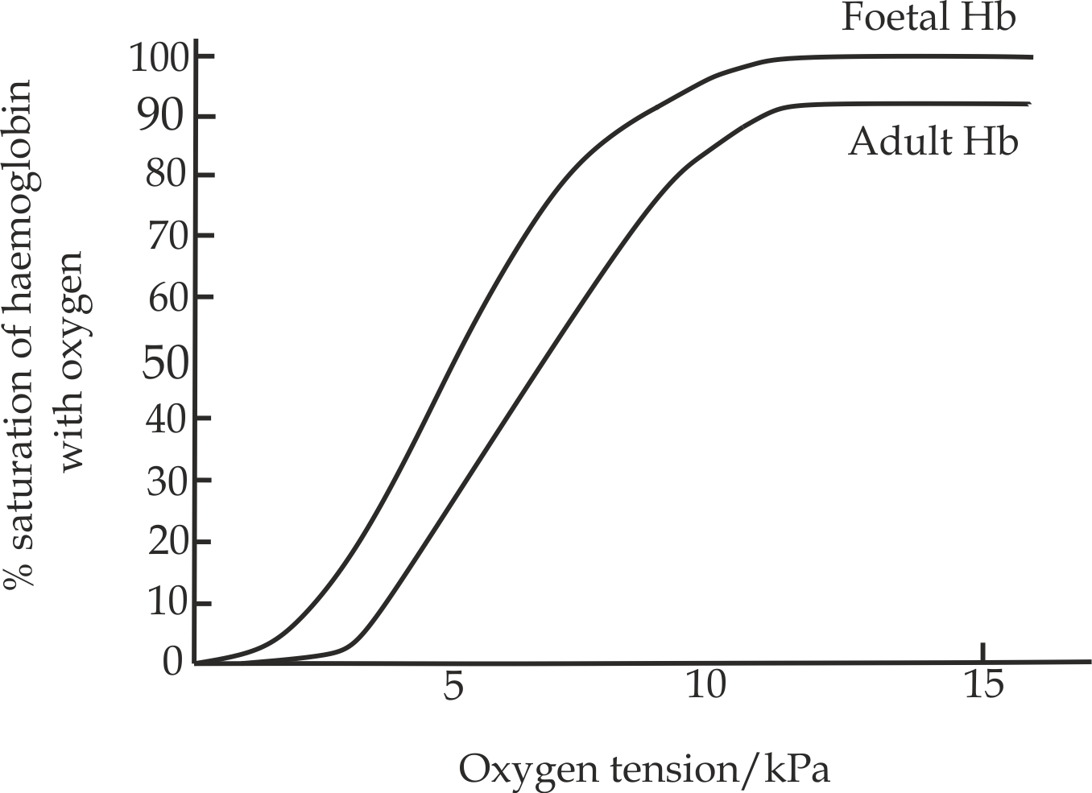

***Fig 4. 17*** *Foetal haemoglobin and adult haemoglobin*



**Sample question – 17**

**Style 1: Tahossa Ilala, Kinondoni and Temeke 2021**

* Explain why babies can stay alive in the womb of their mothers despite the fact that, they are not in direct contact with the atmospheric air?

**Hints:**

Explain the adaptations of foetal haemoglobin.

**Style 2: Tahossa Dar 2021**

Study the graph below and answer the questions that follow:

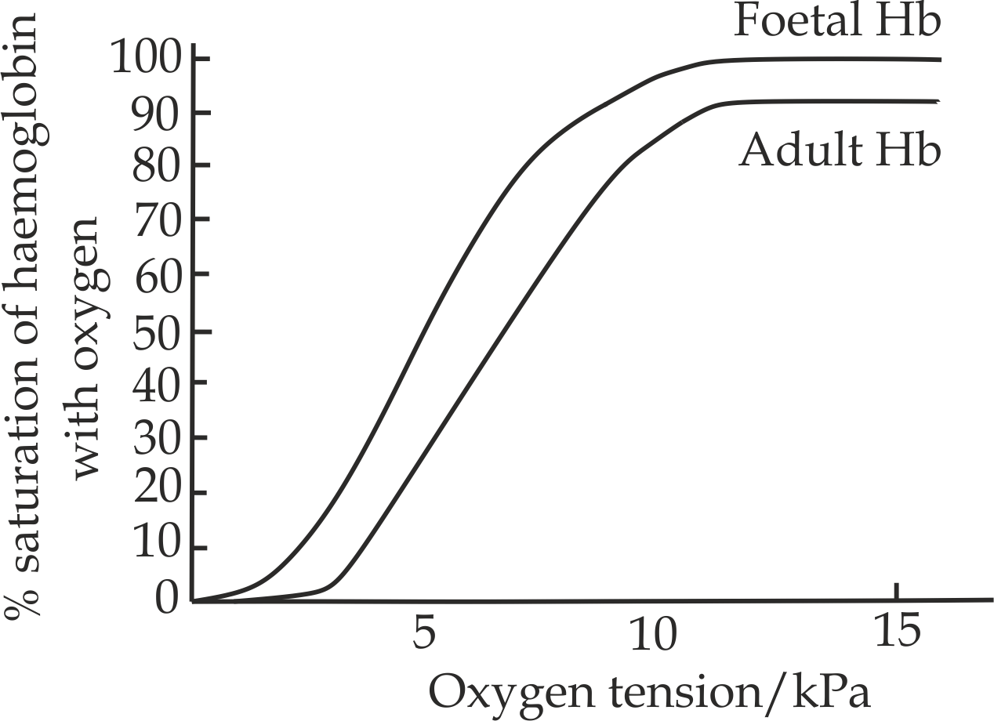

1. What does the graph depict about oxygen intake?
2. Differentiate the two curves in oxygen intake in the blood.

**Hints;**

1. The graph shows the oxygen dissociation curve for foetal haemoglobin and adult haemoglobin; the foetal haemoglobin has more affinity to oxygen, this allows foetal to extract more oxygen.
2. Differences:

* The graph of foetal haemoglobin lies more on the left, while the adult lies more to the right.
* The foetal haemoglobin attracts more oxygen and hence the saturation of haemoglobin is higher in the foetus while adult haemoglobin has less affinity to oxygen.



**4.2.6: Transport of carbondioxide**

In vertebrates; normally carbondioxide is transportedin three (3) different main ways:

1. As a solution form,
2. as carbaminohemoglobin
3. As bicarbonate ion **(HCO3-)**.
4. **As a solution form (5%)**

Carbondioxide gas from the tissues such as muscles, diffuse into the blood plasma and transported as a physical solution form, since carbondioxide is relatively insoluble in water, only **five (5%)** of the total carbondioxide is transported in this way.

1. **As carbaminohemoglobin (15%)**

In the region with low partial pressure of oxygen gas such as muscles tissues, carbondioxide combines reversibly with amino group of haemoglobin to form an intermediate compound known as **carbaminohemoglobin**.

NH2Hb + CO2 CO2NH2Hb

(Hemoglobin) (Carbaminohemoglobin)

In the region with low partial pressure of carbondioxide such as **lung tissues**, normally carbaminohemoglobin easily dissociates to release carbondioxide and haemoglobin.

CO2NH2Hb CO2 + NH2Hb

(Carbaminohemoglobin) (Hemoglobin)

1. **As bicarbonate ion (HCO3-)**

Most carbondioxide (**85%)** in the body is transported as hydrogen carbonate in the blood plasma. In which carbondioxide produced in the tissues diffuse into a blood plasma then passes into red blood cell (RBC) where it combines with water to form carbonic acid under the presence of carbonic anhydrase enzyme in RBC.

The carbonic acid then dissociates into H+ and HCO3-.

*Carbonic anhydrase*

CO2 + H2O H2CO3

H2CO3 H+ + HCO3-

The HCO-3 formed within the red blood cell diffuses out into the plasma along the concentration gradient and combine with sodium in the plasma to form sodium hydrogen carbonate (NaHCO3).

The loose of negatively charged ion from the RBC (HCO3-) leave them with more positively charge. This is balanced by chloride ion (Cl-) diffusing into the RBC from the plasma. This phenomenon is called the **chloride shift** or **Hamburger** shift. It is named after the founder, known as **Hartog Jacob Hamburger.**

When the red blood cell reaches the lungs the reverse process or reaction occurs and carbondioxide gas is released as shown in *Figure 4.18*.

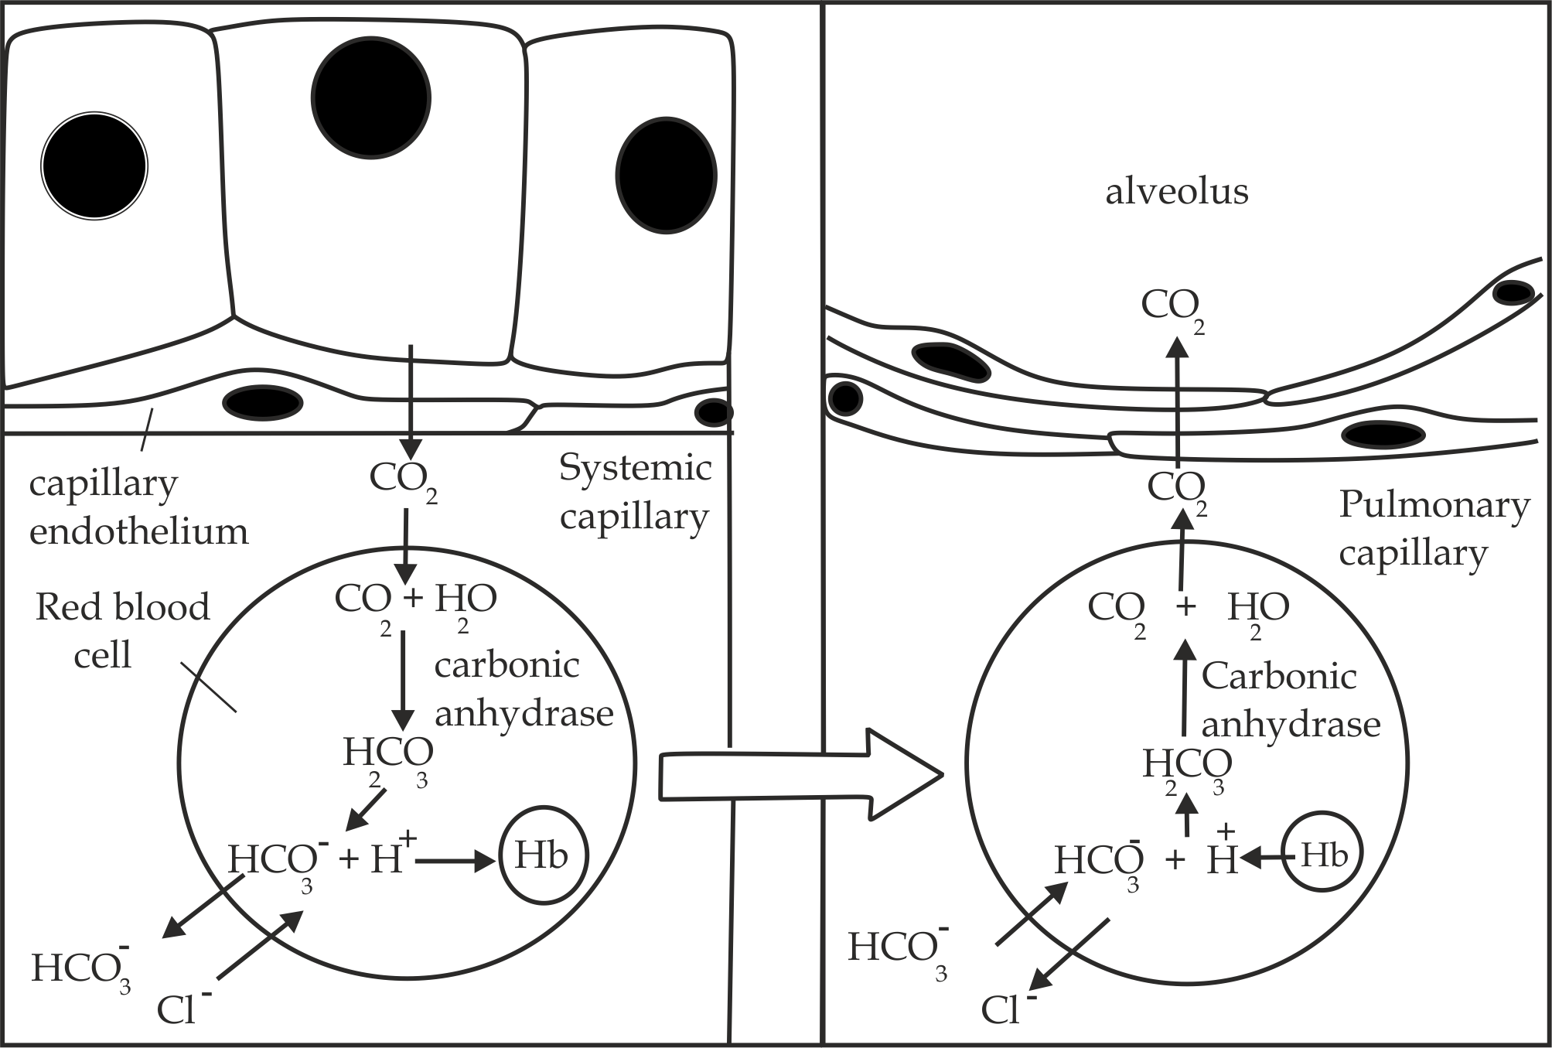

***Fig 4.18*** *Transportation of carbondioxide gas as bicarbonate ion*



**Remember:**

* It is therefore clear that the Bohr Effect is due not to carbondioxide as such, but to the hydrogen ions resulting from its presence.
* In the lungs, oxygen displaces H+ and combines with haemoglobin to form oxyhaemoglobin. This phenomenon is called **Haldane effect.**
* Other materials are also transported in blood. For example, soluble food materials, waste products (urea) and hormones are all conveyed from one place to another in the plasma. The blood also plays an important part in body temperature regulation by the transport of heat all over the body.



**Sample question – 18**

**Jecas 2011**

* 1. Describe the process whereby carbondioxide gas is expelled from the blood in the form of bicarbonate ion.

1. What is the chloride shift? Explain how it occurs.

**4.3. GASEOUS EXCHANGE IN PLANTS**

Plants like any other organisms need to exchange gases; because they respire aerobically and they need to get oxygen and get rid of carbondioxide gas which is the by-product of the respiration process, also still need to get carbondioxide for photosynthesis and get rid of oxygen. However, are not as active as animals. This means that plants possess low rate of metabolism and therefore do not need to have high rate of gaseous exchange.

**What are sites of gaseous exchange in plants?**

Specialized parts for gaseous exchange in plants include stomata, lenticels and cuticle.

1. **Stomata**

These are minute pores boarded by guard cells in the epidermis of leaves. Oxygen from the air diffuses through the stomata and reaches the cells and carbondioxide in a reverse direction. In 1900 a discovery was made by two researchers, **H. T. Brown** and **F. Escombe**, which help to explain why stomata are good at allowing gasses to move in and out of leaves. They showed that a greater volume of gas will pass through numerous small holes in a given time than through a single hole of the same total area by diffusion. Stomata are therefore ideal for gaseous exchange in plants.

1. **Lenticels**

These are area of loosely packed cells in the cork surface of stem or roots that allow interchange of gases between the internal tissues and the atmosphere; For example woody stem and roots such as shrubs and trees diffuse through the lenticels to reach the cells.

1. **Cuticle**

It is an outer waxy layer covering the epidermal cells of the leaves; as stomata close, the exchange becomes slower and the cuticle of the epidermal tissue begins to control the rate of gaseous exchange.

**Mechanism of gaseous exchange in plants (***Figure 4.19***)**

The process of gaseous exchange in plants occurs throughout the day and night; however during the day the rate of photosynthesis can be **10** or even **20** times faster than respiration, this is depending on light intensity. Therefore, the stomata must stay open for longer periods to allow more diffusion of carbondioxide from the atmosphere into the intercellular spaces of the leaf through stomata pores which are normally found on the lower surface of the leaf and gasses diffuse into the cells that require them and oxygen produced from the respiration diffuse down a diffusion gradient from the air spaces of the cells to the atmosphere through the stomata.

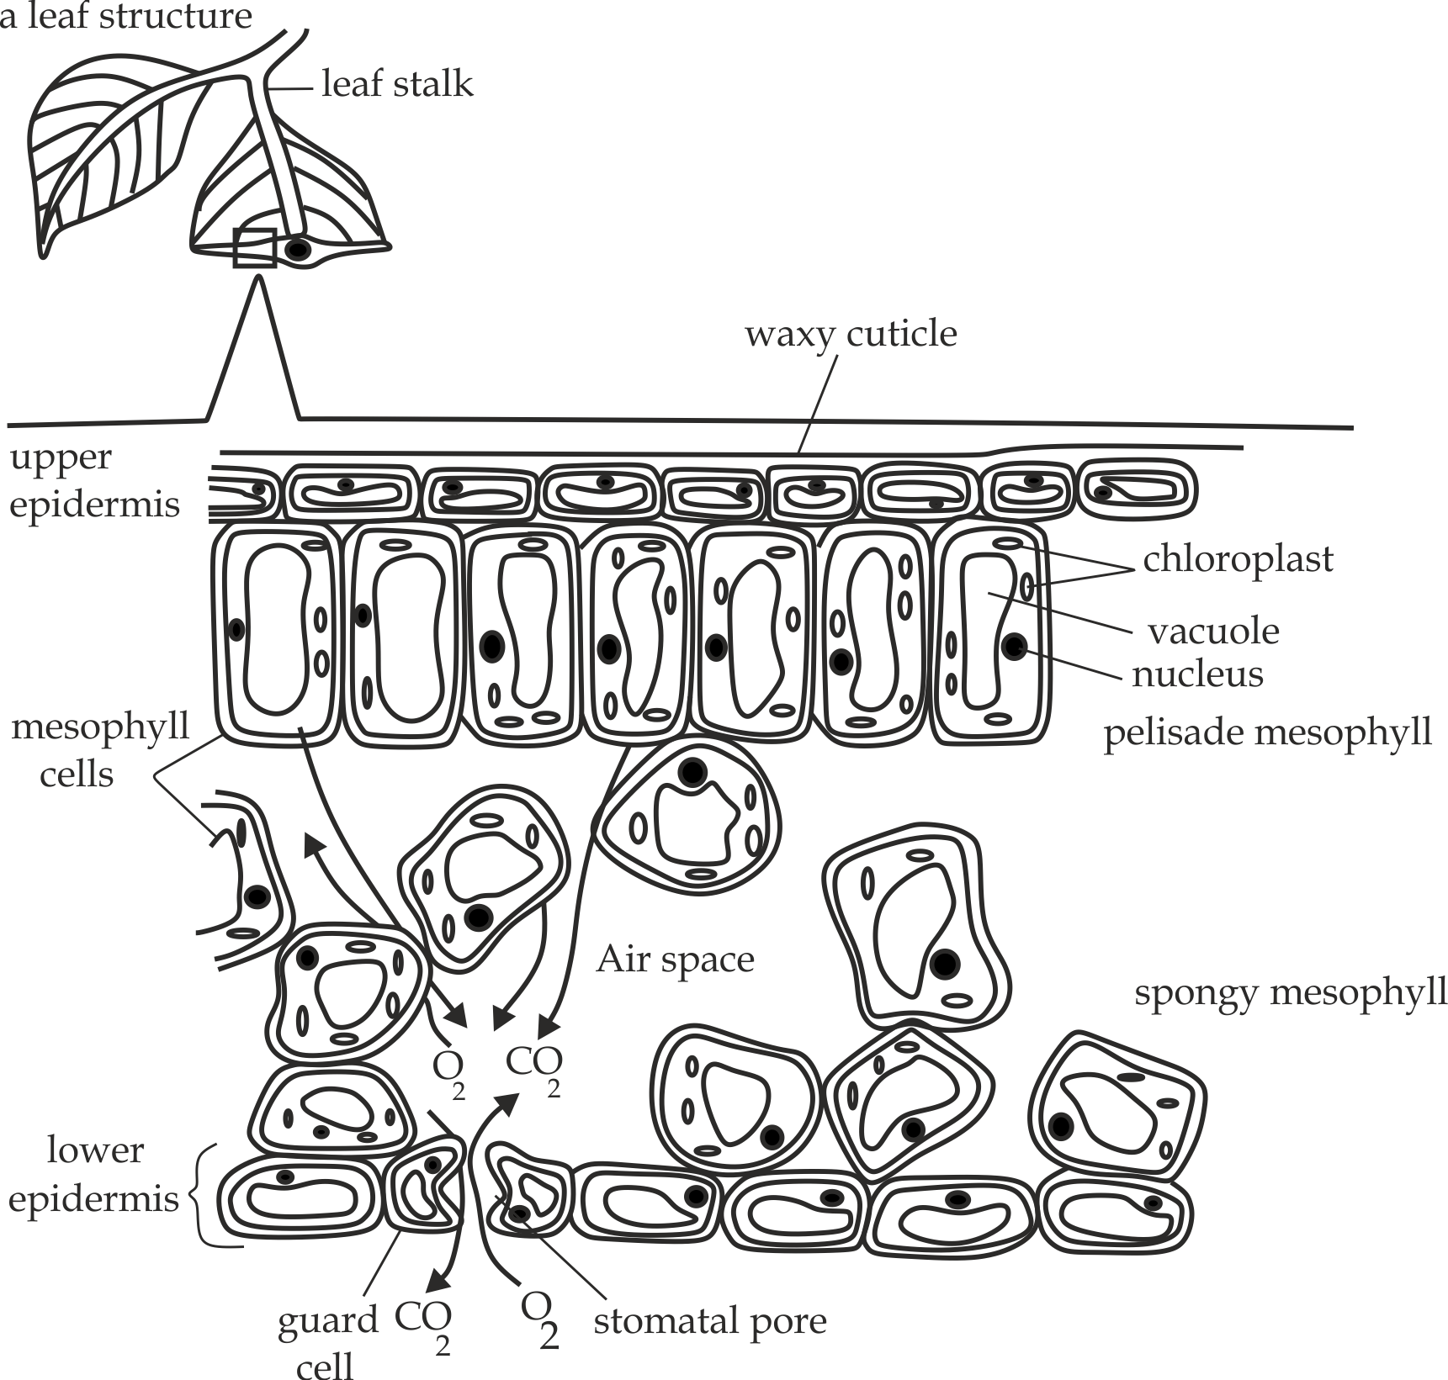

***Fig 4.19*** *Gaseous exchange in plants*

**What are the factors affecting the rate of gaseous exchange in plants?**

The rate of gaseous exchange in plants depends on the opening and closure of the stomata. The opening and closing of the stomata are determined by factors such as humidity, temperature, Size of the stomata pores, light, etc.

1. **Light intensity**

Since stomata open in the presence of the light intensity, then the rate of gaseous exchange tend to increase with increased light intensity.

1. **Temperature**

The higher the temperature the higher the rate of gaseous exchange in plants since temperature favours the kinetic energy for the movement of gasses.

1. **Humidity**

The higher the humidity decreases the rate of gaseous exchange in plants by creating less steep water potential in between the leaf and atmosphere.

1. **Wind**

The rate of gaseous exchange is higher in wind periods because the moving air sweeps away water vapour around the leaf surface by creating a steep water potential gradient between the leaf and atmosphere consequently increases the rate of gaseous exchange.

1. **Availability of soil water**

The rate of gaseous exchange is higher in plants if the amount of soil water is available which provide the oxygen gas to the plant. This is important factor in aquatic plants including phytoplankton such as water lilies and weeds.

**Sample question – 19**

**Famous questions of gaseous exchange in plants**

**Q.1.** State differences between gaseous exchange in plants and mammals.

**Q.2.** Why do plants need to exchange gases with the environment?

**Q.3.** Describe three ways of obtaining oxygen in terrestrial plants.

**Q.4.** Explain briefly the mechanism of gaseous exchange in plants?

**Q.5.** Explain the factors affecting the rate of gaseous exchange in plants.

